1D Space-Time & 2D Space Resolved Hot Electron Generation At Shock Ignition Relevant Parameters

Renner, O^{1,2,3}, Batani, D⁴, Cristoforetti, G⁵, Červeňák, M², Dudžák, R^{1,2}, Filippov, E⁶, Gajdoš, P², Gizzi, LA⁵, Juha, L¹, Korneev, Ph⁷, Koester, P⁵, Krůs, M², Martynenko, A⁸, Nicolai, P⁴, Pikuz, S⁶, Pisarczyk, T⁹, Singh, S^{1,2}, Tentori, A⁴, Tikhonchuk, VT^{3,4}, and Weber, S³

¹Institute of Physics, Czech Academy of Sciences, Prague, Czech Republic
²Institute of Plasma Physics, Czech Academy of Sciences, Prague, Czech Republic
³Extreme Light Infrastructure ERIC, ELI Beamlines Facility, Dolní Břežany, Czech Republic
⁴Université Bordeaux, CNRS, CEA, CELIA, Talence, France
⁵National Institute of Optics, CNR-INO, Pisa, Italy
⁶Joint Institute of High Temperature of RAS, Moscow, Russian Federation
⁷P.N. Lebedev Physical Institute of RAS & MEPHI, Moscow, Russian Federation
⁸IGSI Helmholtzzentrum für Schwerionenforschung GmbH, Darmstadt, Germany
⁹Institute of Plasma Physics and Laser Microfusion,Warsaw, Poland
renner@fzu.cz

Abstract
The kinetics of hot electron (HE) generation accompanying intense laser-matter interaction, detailed mechanisms of their production, and impact on formation of strong shocks and magnetic fields are not fully understood yet. The aim of experiments conducted at the Prague PALS laser facility is to collect precise data needed for development of theoretical models describing the HE formation, transport, and energy deposition inside targets which affect the shock dynamics. Here we report on x-ray measurements characterizing HE generation via 1D space-time and 2D space-resolved imaging of HE-induced Kα emission inside the cold target material. The experiments were performed at laser intensities up to 2×10¹⁶ W/cm², i.e., at parameters of the laser-plasma coupling suitable to address the physics of the laser spike induced shock wave igniting the fusion reaction. We describe the experimental setup and provide examples of HE records observed at different geometry targets.

- INTRODUCTION
The interaction of high intensity laser radiation with solid targets is accompanied by strongly nonlinear phenomena. Despite a progress in theoretical description of relevant processes (Batani et al, 2019, Tikhonchuk, 2019), the laser energy deposition into the target is not fully understood even at moderate intensities 10¹⁵ - 10¹⁶ W/cm². Here the laser energy deposition switches from collisional absorption to mechanisms governed by resonance excitation of large-amplitude plasma waves, namely by stimulated Brillouin (SBS) and Raman (SRS) scattering and two plasmon decay (TPD). In longer scale-length plasmas, these parametric instabilities dominate the generation of hot electrons (hereafter HE) compared to alternate processes, e.g., resonant absorption and vacuum heating.
The detailed investigation of HE production is of paramount interest for fundamental research in the fields of laboratory astrophysics and in general high-energy-density physics (Renner & Rosmej, 2019). The more practical applications refer to the HE role in implementation of diverse scenarios for inertial confinement fusion (ICF). The research reported here belongs to a series of experiments conducted at the PALS laser facility (Jungwirth et al, 2001) at intensities up to 2×10¹⁶ W/cm², i.e., at parameters of the laser-plasma coupling suitable to address the physics of the shock ignition scheme (Batani et al, 2019). The HE generation is characterized via 2D space- and 1D space-time resolved imaging of the HE-induced Cu Kα emission from the target. The 2D resolved data determine the HE dose and spatial distribution, the 1D space-time resolved images corelate the HE evolution with the temporal laser profile. The precisely measured data provide an input needed for benchmarking of novel theoretical approaches to complex modeling of the parametric instabilities growth, HE production and transport in partially ionized targets (Tentori et al, 2022).
- EXPERIMENT
The experiments were performed using the fundamental frequency radiation of the PALS iodine laser (1315 nm, 0.3 ns, ≤600 J). The random phase plate smoothed beam was focused to a focal spot with a FWHM diameter of 100 µm. The detailed description of the experimental complex, as well as a survey of results obtained can be found in papers (Pisarczyk et al, 2018 & 2022, Cristoforetti et al, 2021, Filippov et al, 2023). Here we focus on 2D space and 1D space-time resolved investigation of HE generation via imaging of the HE-induced Kα emission from Cu-containing targets.
The principle of imagers based on spherically bent crystals can be found e.g. in (Renner & Rosmej, 2019). The HEs accompanying the laser-matter interaction collide with inner-shell electrons of Cu which results in 2p → 1s fluorescence. The coincidence between the Cu Kα₁ wavelength (1.5406 Å) and the 2d interplanar spacing (1.5414 Å) of the spherically bent quartz (422) crystal results in quasi-normal diffraction from the crystal. The novelty of our approach consists in absolute calibration of the imaging system via detailed ray tracing (Podorov et al, 2001) which is of paramount importance for quantitative interpretation of 2D resolved images and/or, in a combination with the Hamamatsu high dynamic range x-ray streak camera (XSC), for optimized measurements of temporal corelation between HE-induced signals and the laser profile in case of the 1D space-time resolved imaging.
The experimental setup is depicted in Figure 1. For 2D imaging, both the crystal and the detector are fielded inside the interaction chamber which provides more freedom in a choice of the experimental configuration. In 1D case, the XSC is fixed onto one of the chamber flanges which defines the distance c between the target and XSC slit, thus the system magnification M=b/a and the crystal position are strictly determined. For 2D and 1D systems, the crystals with radii of 380 and 500 mm provided M = 1.7 and 3.96 and the spectral window of approximately 0.8 and 1.4 mÅ. This is sufficient to cover the Cu Kα₁ emission (with the FWHM width of 0.4 mÅ) from the cold Cu but cuts off the Kα₂ component and the frequency shifted Kα emission from the heated target (Renner et al, 2016). The ray traced transfer function of imagers related 1 Cu Kα₁ photon emitted from the source into the full solid angle to ~1.3×10⁻⁶ and 8.9×10⁻⁷ photons incident on the detector, respectively.
The spatial resolution of the 2D imager recalculated to the target plane was limited by the signal spreading in the IP used (Fuji MS and SR type) to about 30 µm. In 1D imaging scheme optimized for meridional diffraction, the Cu Kα1 image was projected onto the XSC entrance slit with dimensions of 18 mm × 80 µm (space × time resolving direction). In this case, the spatial resolution corresponds to about 4 µm. With respect to the sweeping speed used (average value 5.35 ps/px), the temporal smearing of the recorded signal equals to approximately 33 ps. The absolute temporal calibration of the HE-induced Cu Kα₁ profiles was provided via a frequency tripled fiducial split-off from the main laser beam brought onto the XSC slit. The observed variable spacing between the fiducial and the time-space resolved image of the HE action was then used to determine the absolute temporal delay between the laser profile and the time-resolved HE signal. More details about the 1D space-time resolved HE-induced Cu Kα imaging will be published elsewhere (Renner et al, 2023).

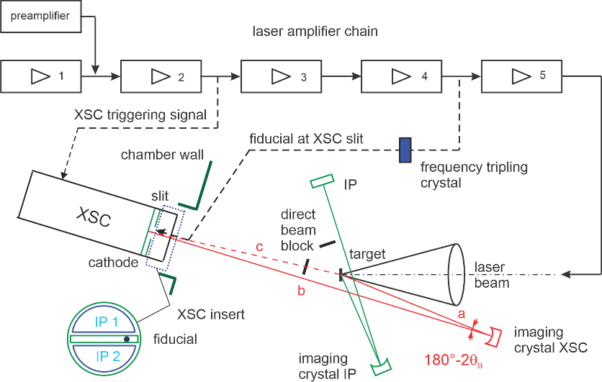
Figure 1. A scheme of the imaging system combining the spherically bent crystal diffractors with time resolving (x-ray streak camera, XSC) or time integrating (imaging plate, IP) detectors.
- RESULTS AND DISCUSSION
The diagnostic potential of the described methods is illustrated on several examples of 2D and 1D space-time-resolved imaging of HE generation in Cu-containing targets. Both records presented in Fig. 2 relate to investigation of magnetic fields produced at laser irradiated targets. Figure 2a indicates the HE energy deposition in the snail-shape target. The HE interaction peaks near the shallow-angle laser impact close to the snail entrance but slowly decays along its whole internal surface. This long interaction length leads to a very efficient laser energy deposition in the target affecting the magnetic field formation. The full dose of created HEs was estimated by using the GEANT4 code (Agostinelli et al, 2003) to 1.5 J. Details of this methodology are presented in the paper Pisarczyk et al (2018).

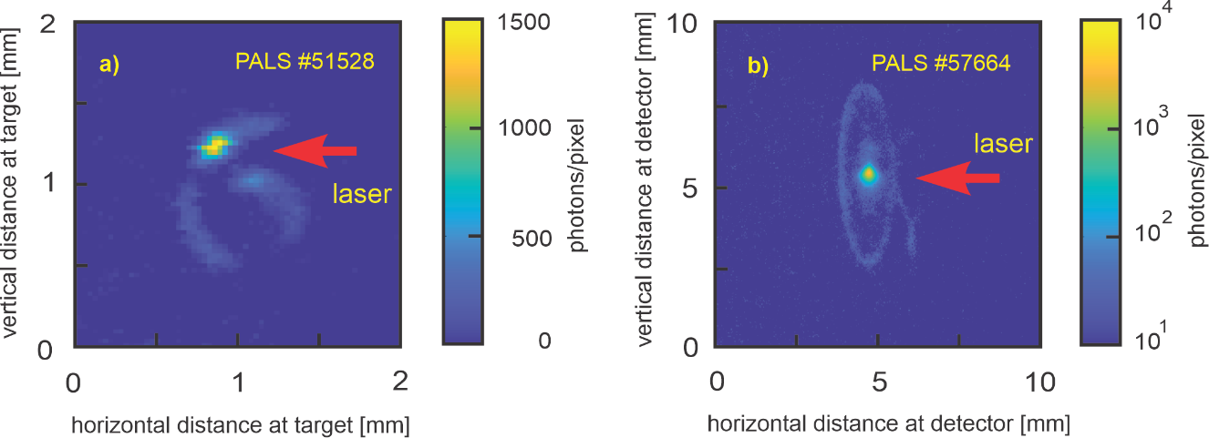

Figure 2. Hot electron deposition along the surface of the laser irradiated snail-shape target (a) and in the disc target connected to the coil (b).
Figure 2b bears upon optical generators of strong magnetic fields based on the laser driven coil-target concept. The 50-µm-thick Cu disk coupled to a grounded single-turn coil was irradiated by the laser beam with an energy of 500 J. The experiment aimed at investigation of the coil-induced magnetic field effect on the ablative plasma, in particular on generation of HEs and ions responsible for transport of the laser energy to the shock wave. The experimental data proved that the presence of the axial magnetic field leads to an increased collimation of HE fluxes and to enhanced production of higher-energy HEs, i.e., to the increased laser energy conversion to HEs (Pisarczyk et al, 2022).
The examples of the time resolved measurements of the HE generation in bare Cu and structured targets with Cu tracing layer are presented in Fig. 3. Temporal correlation of the HE induced Cu Kα₁ emission with the laser beam irradiating the massive Cu target is shown in Fig. 3a. The rising edge of the HE signal is delayed by 86±45 ps vs that of the laser profile, the HE maximum lags behind the laser by 19±45 ps. In contrast, the rising edge of the HE production observed at composite targets with Al ablator practically coincides with the laser profile and the HE maximum even precedes that of the laser, see Figure 3b. This behavior reflecting the diverse kinetics of the HE generation at targets with different atomic numbers agrees with conclusions of CHIC code modeling (Llor Aisa et al, 2017) but a conclusive interpretation of observed phenomena should be confirmed by advanced simulations.

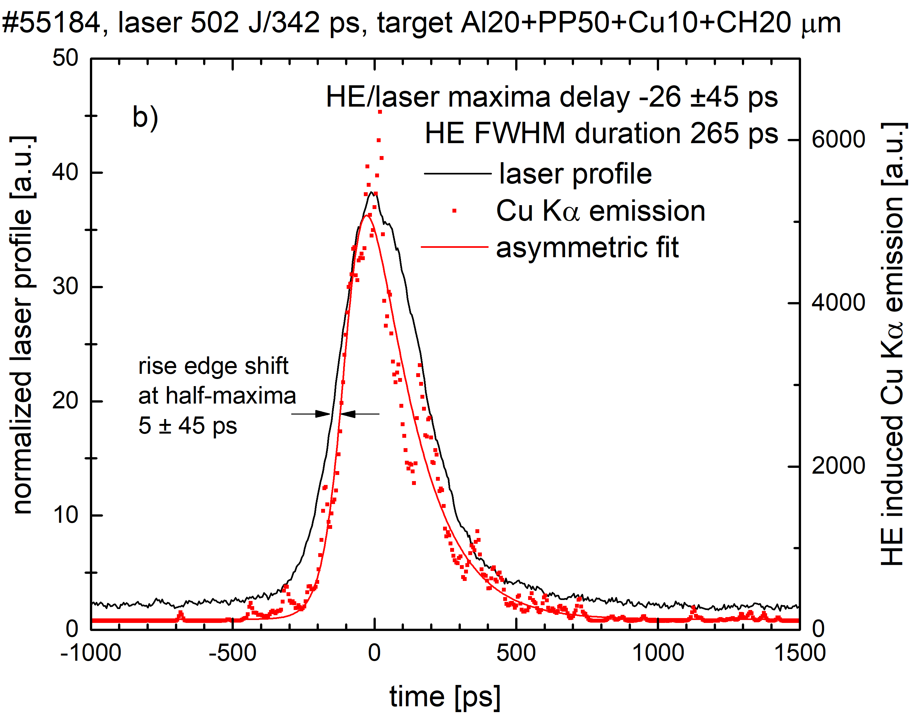
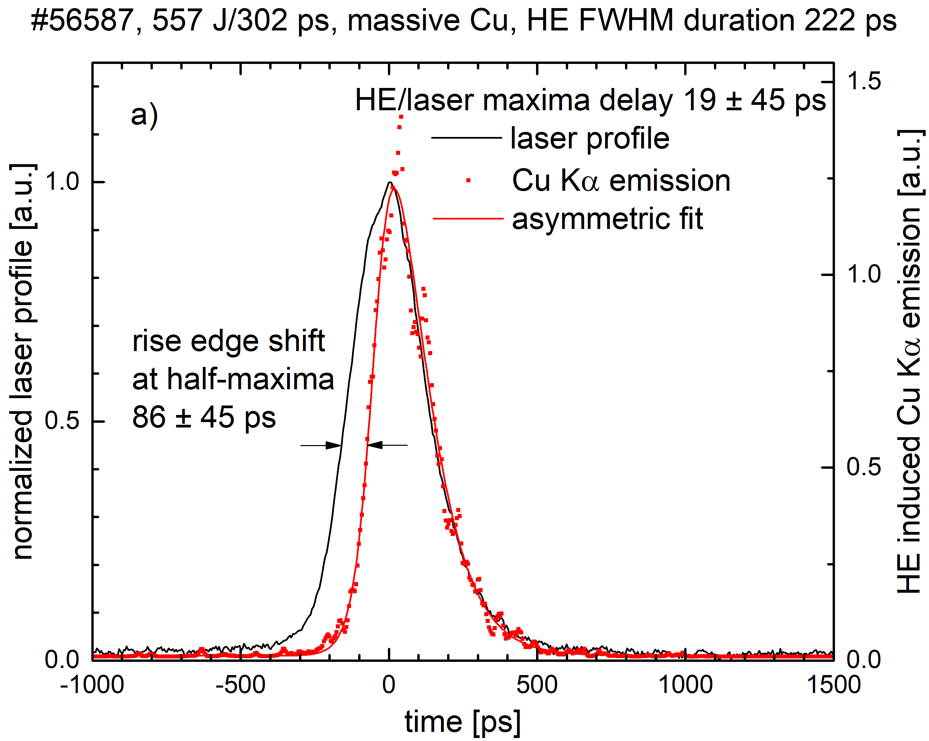
Figure 3. Time resolved hot electron emission from the massive Cu target (a) and the structured target with the Al ablator and the Cu tracing layer (b) absolutely calibrated vs the plasma producing laser beam.
- CONCLUSION
The 1D space-time and 2D space resolved methods of x-ray imaging based on measurements of the HE-induced K-shell emission from the laser irradiated targets containing Cu atoms are capable of providing direct information on fundamental properties of the produced HEs including their formation temporally related to the laser profile, energy deposition and transport in the target material. The understanding of these characteristics and processes connected with the HE generation contributes to a detailed interpretation of diverse phenomena accompanying the laser-matter interaction and, in particular, to the practical realization of one of the ICF scenarios.

- ACKNOWLEDGMENT
The authors acknowledge a support of the PALS Infrastructure within the MŠMT (MEYS) project No. LM2023068. This work has been carried out within the framework of the EUROfusion Consortium, funded by the European Union via the Euratom Research and Training Programme (Grant Agreement No 101052200 — EUROfusion). Views and opinions expressed are however those of the authors only and do not necessarily reflect those of the European Union or the European Commission. Neither the European Union nor the European Commission can be held responsible for them. The involved teams have operated within the framework of the Enabling Research Project: ENR-IFE.01.CEA “Advancing shock ignition for direct-drive inertial fusion".

- REFERENCES
Agostinelli S. et al (2003). GEANT4 simulation toolkit. Nucl. Instr. Methods Phys. Res., A 506: 250.
Batani D. et al (2019). Progress in understanding the role of hot electrons for the shock ignition approach to inertial confinement fusion. Nucl. Fusion, 59: 032012.
Cristoforetti G. et al (2021). Observation and modelling of stimulated Raman scattering driven by an optically smoothed laser beam in experimental conditions relevant for Shock Ignition. High Power Laser Sci. Eng. 9: e60.
Cristoforetti G. et al (2023). Investigation on hot electron origin in laser plasma interaction at Shock Ignition intensities. (in preparation).
Filippov E.D. et al, (2023) Characterization of hot electrons generated by laser-plasma interaction at shock ignition intensities., Submitted to Matter Radiat. Extremes.
Jungwirth K. et al (2001). The Prague Asterix Laser System PALS. Phys. Plasmas, 8:2495.
Llor Aisa E.L. et al (2017). The role of hot electrons in the dynamics of a laser-driven strong converging shock. Phys. Plasmas 24: 112711.
Pisarczyk T. et al (2018). Magnetized plasma implosion in a snail target driven by a moderate intensity laser pulse. Sci. Reports, 8: 17895.
Pisarczyk T. et al (2022). Influence of the magnetic field on properties of hot electron emission from ablative plasma produced at laser irradiation of a disc-coil target. Plasma Phys. Control. Fusion, 64: 115012.
Podorov S.G. et al (2001). Optimized polychromatic x-ray imaging with asymmetrically bent crystals. J. Phys. D: Appl. Phys. 34: 2363.
Renner O. et al (2016). Suprathermal electron production in laser-irradiated Cu targets characterized by methods of x-ray imaging and spectroscopy. Plasma Phys. Control. Fusion 58: 075007.
Renner O. and Rosmej F.B. (2019). Challenges of x-ray spectroscopy in investigations of matter under extreme conditions. Matter Radiat. Extremes, 4: 024201.
Renner O. et al (2023). Time resolved x-ray imaging of hot electron generation at shock ignition relevant laser-target coupling parameters. (in preparation).
Tikhonchuk V.T. (2019). Physics of laser plasma interaction and particle transport in the context of inertial confinement fusion. Nucl. Fusion, 59: 032001.

