Impact of ambient temperature on the filter polychromators performance and accuracy of Thomson scattering diagnostics

T.C. Zhang, Z.B. Shi, S.B. Gong, W.P. Guo, Z.P. Hou, C.H. Liu, W.Y. Zhai, B.H. Deng
Southwestern Institute of Physics, Chengdu 610041, People’s Republic of China
*E-mail : zhangtongchuan@swip.ac.cn

Thomson scattering is one of the most important diagnostic methods for measuring plasma electron temperature and electron density. However, the performance of the avalanche photodiodes (APD) used in polychromators is greatly affected by the ambient temperature, and subsequently the change of ambient temperature will seriously affect the accuracy of Thomson scattering diagnostics. With the increase of ambient temperature from 17.7 to 21 degrees, the signals of all measuring channels of the polychromator are significantly reduced by ~30% (Fig. 1). Using the relative spectral response measured at different ambient temperatures, the electron temperature and electron density can be obtained. When the ambient temperature rises from 17 ℃ to 27 ℃, the electron temperature changes within ± 2%, while the electron density decreases by about a factor of 2. In general, the ambient temperature has little influence on the measurement of electron temperature, but has a greater influence on the electron density. These measurement and modeling results show that tight control and monitoring of the ambient temperature is required for high quality Thomson scattering diagnostic measurements.
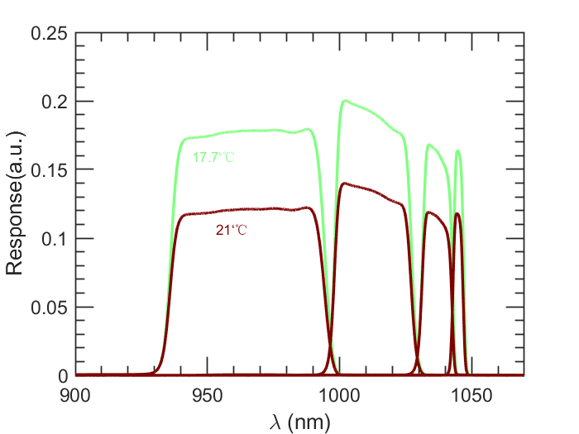
Fig.1. Relative spectral response of the polychromator at 17.7℃ and 21℃

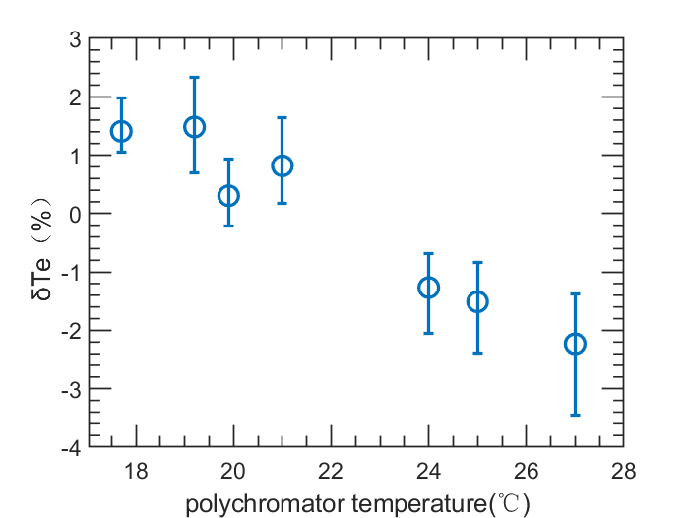
Fig.2. Calculated electron temperature with the polychromator spectral response at different ambient temperature

