Visible imaging diagnostics for high-performance plasmas on the HL-2M tokamak

L. Liu, D.L. Yu, F. Xia, S.Q. Wang, W.J. Chen, X.X. He, Y.L. Wei, and Z.B. Shi
Southwestern Institute of Physics, Chengdu 610041, China

The main missions of HL-2M are to support the operation of International Thermonuclear Experimental Reactor (ITER) and the design of future fusion devices in integrating both the technological and physics aspects. HL-2M features ultrahigh vacuum, large current, strong magnetic field, and intense radiation. Therefore, design of the imaging systems should be ingenious enough to make them run normally on the HL-2M. Three visible imaging diagnostics, including a tangential view, an extreme wide-angle view and a downward-looking diagnostic, are installed on the HL-2M tokamak for the high-performance plasmas. The entire field of view (FOV) covers up to 80% of the vacuum vessel. They aim at meeting the requirements of safe machine operation, plasma position control, MHD instabilities study, etc.
The field of the extreme wide-angle view reaches 112°, which is the widest for regular operation among large tokamaks. Without showing the distortion of conventional wide angle lenses, it opens up new opportunities for the high-temperature plasma studies, as shown in Fig. 1(a). The multifaceted asymmetric radiation from the edge (MARFE) phenomenon is specially observed by the extreme wide-angle view, as shown by the bright radiation around the central column in Shot 1525 in Fig. 1(b). It is a nearly toroidally symmetric and poloidally asymmetric band at high field side near the plasma boundary, which starts to grow up (in this case of Shot 1525, beginning at about 1000 ms) as the electron density exceeds a high value. Two types of motion behaviors have been observed: (a) remaining fixed in poloidal position and (b) moving downwards poloidally just before the plasma disruption.

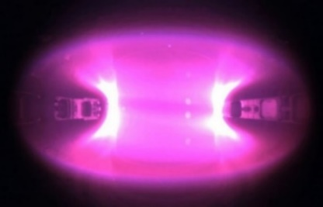
(a)
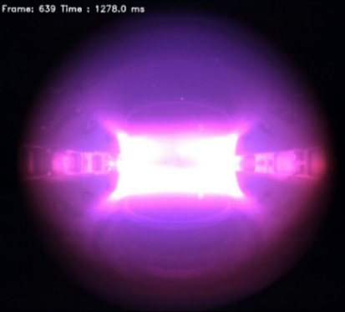
(b)
Fig. 1. Photographs of the vacuum vessel and plasmas with the extreme wide-angle view diagnostic at (a) 1032 ms in Shot 1515, and (b) 1278 ms in Shot1525.

