ANGULAR-RESOLVED THOMSON PARABOLA SPECTROMETER FOR
LASER-PLASMA ION ACCELERATORS
C. Salgado-López¹, J.I. Apiñaniz¹, A. Curcio², D. de Luis¹, J. L. Henares¹, J. A. Pérez-Hernández¹, L. Volpe^{1,3} and G. Gatti¹

¹Centro de Láseres Pulsados (CLPU), Salamanca, Spain.
²Laboratori Nazionali di Frascati (INFN-LNF), Frascati, Italy.
³Universidad Politécnica de Madrid (UPM), Madrid, Spain.
csalgado@clpu.es
Abstract
Laser-plasma driven accelerators have become reliable sources of low-emittance, broadband and multi-species ion beams, presenting cut-off energies above the MeV-level. We report on the development, construction, and experimental test of an angle-resolved Thomson Parabola (TP) spectrometer for laser-accelerated multi-MeV ion beams which is able to distinguish between ionic species with different 𝑞/𝑚 ratio. The angular resolving power is achieved due to an array of entrance pinholes and it can be simply adjusted by modifying the geometry of the experiment and/or the pinhole array itself. The analysis procedure allows different ion traces to cross on the detector plane, which greatly enhances the flexibility and capabilities of the detector. A full characterization of the TP magnetic field has been implemented into a relativistic code developed for the trajectory calculation of each beamlet. High repetition rate compatibility is guaranteed by the use of a microchannel plate (MCP). We describe the first test of the spectrometer at the 1 PW VEGA 3 laser facility at CLPU, Salamanca (Spain), where up to 15 MeV protons and carbon ions from a 3-micron laser-irradiated metallic foil are detected.

- INTRODUCTION
Since the invention of the Chirped Pulse Amplification (Strickland & Mourou, 1985), the range of accessible light intensities on focus for ultrabright lasers has only increased. Such enhancement paved the way for laser-plasma particle accelerators (LPA), mainly focused on ions (Macchi, 2013) and electrons (Esarey, 2009). The applications of such accelerated beams profit from the low-emittance and ultrashort duration of the beams, well-fitted characteristics for practical employments. Specifically, since the demonstration of collimation and monochromatisation of LPA multi-MeV ion beams (Ter-Avestiyan, 2008), their potential employments have attained plenty of attention, including fast ignition of inertial confinement fusion reactions (Roth, 2001) and medical purposes (Spencer, 2001) among others.
Due to the specific LPA beam characteristics, one of the most widely used diagnostics for laser-driven ion accelerators are Thomson Parabola spectrometers (Thomson, 1907). First developed by Thomson in 1907, they are in-line diagnostics which sort the particles depending on their energy, momentum and charge-to-mass ratio. The latter is specially useful in LPA scenario where the acceleration of multi-species beam is frequent. The main drawback of TPs is the incapability of deconvolving the spatial distribution of the measured beam as only a particular angle of the beam with an insignificant spread is evaluated because of the use of an entrance pinhole mask. Previous studies with different detectors, focused on analyzing the spatial structure of the beams, showed that the most common laser based ion acceleration mechanism, the Target Normal Sheath Acceleration or TNSA (Macchi, 2013), emits extraordinarily low-emittance beams from a source with a diameter as big as a few hundreds of micrometers and a total beam divergence of 20º. In order to retrieve spatial information about the beam other methods could be use, as stacks of radiochromic films or scintillators (Huault, 2019) which nevertheless fail when attempting to have fine spectral resolution. We present a multi-pinhole Thomson Parabola spectrometer, which combines sharp spectral and angular accuracy, besides the ionic species sorting capability.

- DESIGN
Thomson Parabola spectrometers work according to magnetic an electric sector spectrometer principle. The entrance pinhole selects a beamlet composed by ions with specific 𝑞/𝑚. Parallel (or anti-parallel) magnetic (𝐵) and electric (𝐸) dipoles deflect the ions in orthogonal directions. Such particles are detected in a two-dimensional spatially resolved particle-sensitive detector. In paraxial approximation with perfect fields, the particles will draw a parabolic trace onto the detector (given simply by Lorentz force) as
 | $$y^{2}=\frac{q}{m}\frac{B^{2}l_{2}l_{3}}{E}x$$ | [1]
where 𝑙₂ dipole length and 𝑙₃ the particle free flight distance after the deviation, being the fields parallel to the x-axis. As seen, different charge-to-mass ratio particles will describe different traces and the position of the particle onto the trace will describe its kinetic energy.
We propose a modification of the basic TP design which consist on the substitution of the entrance pinhole by a mask in which several pinholes are drilled. The array of holes chops the incoming beam into several beamlets which are simultaneously detected, resulting in a tomography-like spectral measurement with tunable spatial-resolved information (Salgado-López, 2022). Fig. 1 shows the basic device design.
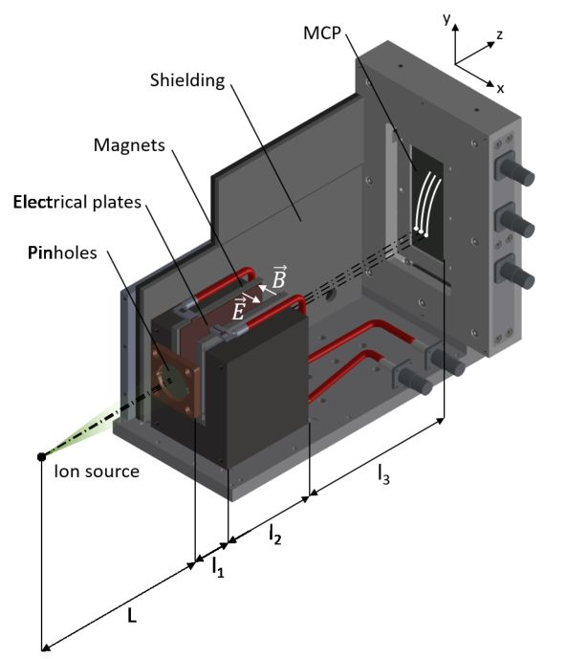
Figure 1. Multi-pinhole TP spectrometer design.

Previous works (Chen, 2010, Ter-Avestiyan, 2010, Yang, 2016) showed similar measurement strategies but most of the cases dismissing the electric field (and therefore the 𝑞/𝑚 differentiation) or limited their detection geometries in order to avoid crossing traces on the detector (Zhang, 2018). We propose a more general approach of such device which can apply the electric and magnetic field for identifying different 𝑞/𝑚 ions and measuring their spectrum at different beamlets backed by a generic post-processing method which accounts for trace crossing. A three-dimensional numerical solver was developed for trajectory simulation and provides the expected traces and the energy-position relation for the required species, which includes a Hall probe characterization of the magnetic field. In the presented configuration proton energies between 300 keV and 25 MeV are accessible; uncertainty at 20 MeV has been estimated to be around 1 MeV.
Trace crossings at the detector produce peak artifacts in the spectrum. Interpretation of such events starts with the identification of the species involved in each cross. Only artifacts producing significant distortion are treated; the peaks that are still observable after applying a Gaussian smoothing over the data are removed, by removing the relevant peak width and performing a linear interpolation between the gap edges. Such interpolation is considered to follow the data trend within its root main squared deviation.
- RESULTS
In this section we show the experimental test of the detector. Both were performed at the VEGA 3 petawatt laser facility at Centro de Láseres Pulsados (CLPU, Spain). VEGA 3 is a Titanium:Sapphire system (𝜆 = 0.8 μm) which delivers p-polarized pulses, up to 30 J and as short as 30 fs. The pulses are focalized by a F/11 off-axis parabolic mirror into a 10 μm full width at half maximum, which implies an averaged laser intensity over 10¹⁹ W/cm². The target was a micrometric-thick Al planar foil irradiated at 10º from the target normal in the horizontal plane.
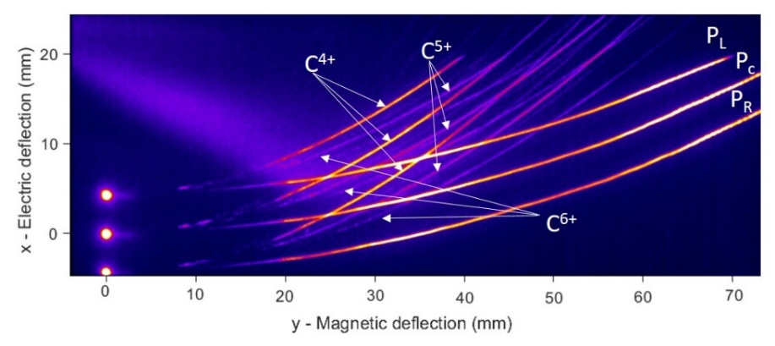
Figure 2. Multi-pinhole TP traces from a single laser shot at VEGA 3.

In the first commissioning test ion acceleration was detected by the multi-pinhole set at a distance from the source 𝐿 = 508 mm. A microchannel-plate (MCP) attached to a phosphor screen was used as active detector, which has the advantage of being well-fitted for high repetition rate (HHR) operation. As shown in fig. 2, traces were imaged onto a scientific CMOS with a calibrated imaging system. The mask in this case was made of a W substrate with 𝑛 = 3 drilled pinholes of 𝑑 = 200 μm evenly separated by 𝑎 = 3 mm.

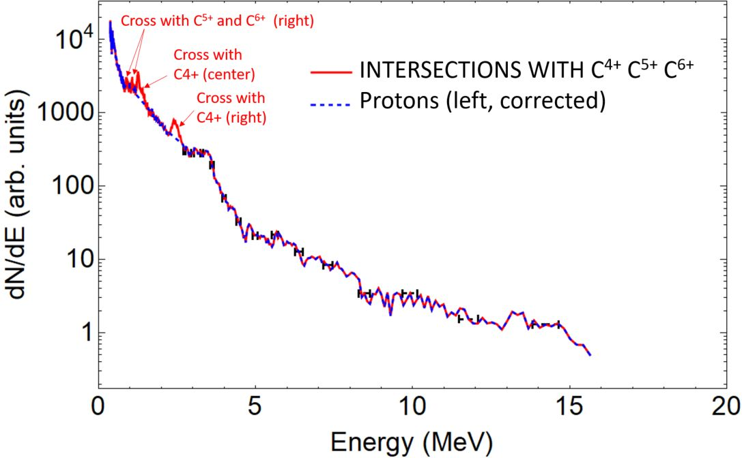
Figure 3. Left beamlet proton (PL) spectrum from fig. 2. Dashed blue: corrected spectrum. Red: raw spectrum.
A single beamlet proton spectrum is plotted in fig. 3, together with the traces intersection signal which are removed. In such geometrical configuration, the separation between the angles probed (𝛼 ≈ 𝑎/(𝐿) = 0.3◦) is small when compared to the total divergence of the beam. Therefore modest differences between different beamlet spectra are expected. Such conjecture is confirmed after the data analysis, as seen in the spectra shown in fig. 4.

- CONCLUSION
A newly developed diagnostic tool is presented. Its operation is based on the Thomson Parabola working principle and therefore able to differentiate between ionic species and presents a fine and wide spectral range of detection, which makes it well-fitted to measure characteristics of typical laser-driven ion beams. Furthermore, tomography-like measurements of the beam with varying angular resolution can be performed thanks to a mask of entrance pinholes. A post-processing method is introduced, making possible to account for trace crosses at the detector plane.
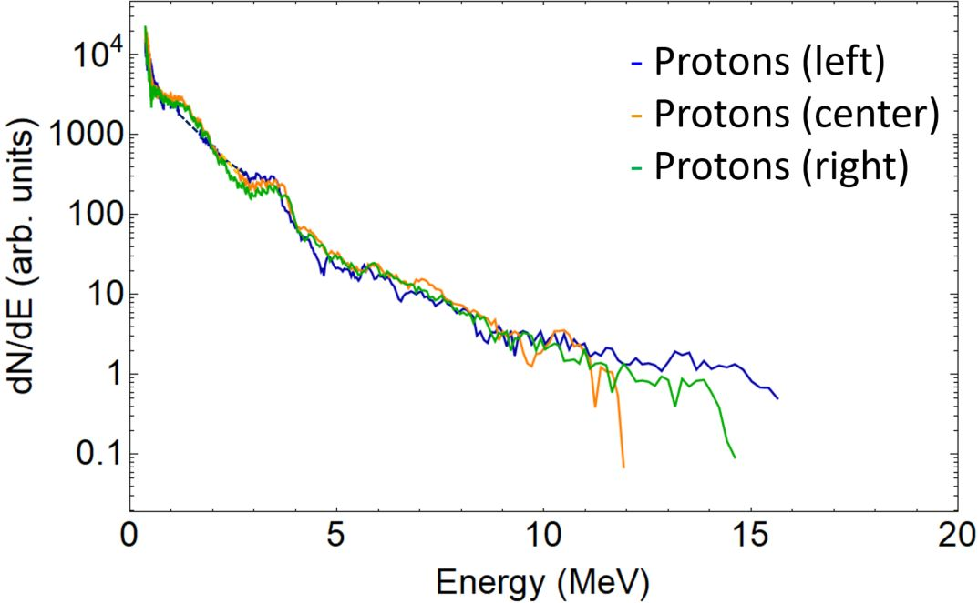
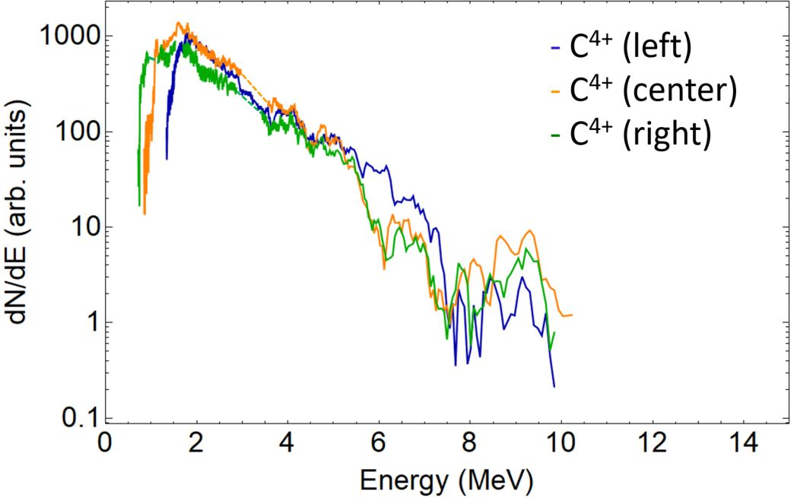
Figure 4. Left: proton energy spectra from left, center and right beamlets (PL, PC and PR traces of fig. 2). Right: C4+ energy spectra from left, center and right beamlets of fig. 2.
- ACKNOWLEDGMENT
Funding from LASERLAB-EUROPE V (Grant Agreement No. 871124, EU Horizon 2020 research and innovation program), IMPULSE (Grant Agreement No. 871161, EU Horizon 2020 research and innovation program) and Grant No. CLP263P20 (Junta de Castilla y León) are acknowledged.

- REFERENCES
Bolton, P. et. al., (2014). Instrumentation for diagnostics and control of laser-accelerated proton (ion) beams. Physica Medica, 30: 255-270.
Chen, H. et. al., (2010). An imaging proton spectrometer for short-pulse laser plasma experiments. Rev. Sci. Instrum., 81: 10D314.
Esarey, E. et. al., (2009). Physics of laser-driven plasma-based electron accelerators. Rev. Mod. Phys., 81: 1129-1285.
Huault, M. et. al., (2019). A 2D scintillator-based proton detector for high repetition rate experiments. High Power Laser Sci. Eng., 7.
Humphries, S. (2002). Charged Particle Beams. Jhon Wiley and Sons.
Macchi, A. and Borghesi, M. and Passoni, M. (2013). Ion acceleration by superintense laser-plasma interaction. Rev. Mod. Phys., 85: 751.
Roth, M. et. al., (2001). Fast Ignition by intense laser-accelerated proton beams. Phys. Rev. Lett., 86: 433-439.
Salgado-López, C. et al. (2022). Angular-resolved Thomson Parabola spectrometer for laser-driven ion accelerators. Sensors, 22.
Spencer, I. et. al., (2001). Laser generation of proton beams for the production of short-lived position emitting radioisotopes. Nucl. Instrum. Methods Phys. Res. Sect. B., 183: 449-458.
Strickland, D. and Mourou, G. (1985). Compression of amplified chirped optical pulses. Opt. Commun., 55: 447-449.
Ter-Avestiyan, S. et. al., (2008). First demonstration of collimation and monochromatisation of a laser accelerated proton burst. Laser Part. Beams, 26: 637-642.
Ter-Avestiyan, S. et. al., (2010). Tomography of an ultrafast laser driven proton source. Phys. Plasmas, 17: 063101.
Thomson, J. (1907). On rays of positive electricity. Lond. Edinb. Dublin Philos. Mag. Sci. 13: 561-575.
Yang, S. et. al., (2016). A two-dimensional angular-resolved proton spectrometer. Rev. Sci. Instrum., 87: 103301.
Zhang, Y. et. al., (2018). An angular-resolved multi-channel Thomson parabola spectrometer for laser-driven ion measurements. Rev. Sci. Instrum., 89: 093302.

