CVD Diamond Tomography for the DTT Fusion Device
Bombarda, F.¹, Palomba, S.², Cesaroni, S.¹, Verona, C.², Verona-Rinati, G.², Marinelli, M.², Angelone, M.¹, Iafrati, M.¹
¹ ENEA, Fusion and Nuclear Safety Department, Frascati (Rome), Italy
² “Tor Vergata” University of Rome, Industrial Engineering Department, Rome, Italy

silvia.palomba@uniroma2.it

Abstract
The conceptual design of the tomography system for DTT is advancing on both the selection of the detectors’ characteristics and on the reconstruction of phantom emission profiles to determine the best combination of the detectors number and position. Single crystal CVD diamonds are likely the most viable choice to place in close proximity of the plasma for UV and SX detection. The new configuration of CVD detector for lateral irradiation (LAT) was designed for a more efficient detection of photons up to 30 keV, while the standard layered configuration is sensitive to energies as low as 5.5 eV up to 2-3 keV. A pixel-based code was developed that utilizes the minimization of χ² with the Tikhonov regularization matrix. The simulations carried out so far indicate that about 96 diodes suitably distributed on the four available ports of the machine are an adequate number for proper reconstruction of simple gaussian phantoms, provided good coverage of the outer edge region is ensured.

- INTRODUCTION
The DTT tokamak (Ambrosino et al., 2021), presently under construction at Frascati (Rome, Italy), is a relatively large device of major radius R = 2.19 m, minor radius a = 0.70 m, toroidal field on axis B_{T} = 6 T, plasma current I_{p} = 5.5 MA. The pulse length is expected to reach 100 s, with plasma density and temperature of 1.8×10²⁰ m⁻³ and 6.1 keV respectively, when heated by 45 MW of additional power. Even if designed to operate with Deuterium fuel, the neutron and gamma radiation fluxes will pose substantial challenges for any diagnostic system required to operate in the proximity of, or inside the vacuum vessel. In such harsh environment, the suitability of Si or CdTe diodes for full plasma tomography is not obvious and requires careful assessment.
For this reason, and also to extend the accessible spectral range, the use of a different kind of UV-SX photon detectors diodes is proposed, namely the thin single crystal, Chemical Vapor Deposition (CVD) diamond detectors being produced at the laboratory of Industrial Engineering Department of the University of “Tor Vergata” in Rome. These have been successfully tested on JET (Angelone et al., 2010) and FTU (Bombarda et al., 2021), but never in full tomographic layout (in fact only two detectors were installed on each machine), and their locations were so removed from the torus that both radiation and heat could not be of concern. Even with just single line-of-sights, they proved capable of providing valuable information of the plasma behavior and its dynamics.

- Characteristics of CVD diamond photodetectors
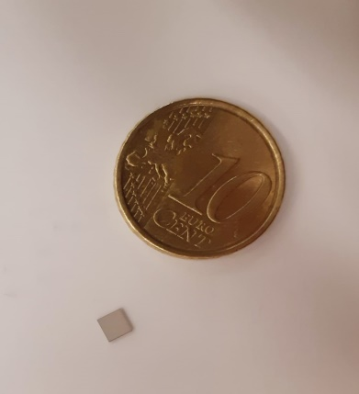
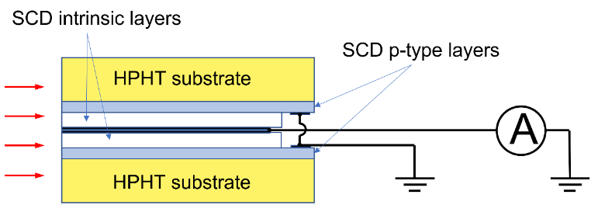
The CVD diamonds exhibit a number of attractive features: they are sensitive to radiation from 5.5 eV up to tens of keV but are visible blind; the wide band gap ensures low leakage currents; they are much more radiation resistant than silicon, especially the thin samples suitable for photon detection. Irradiation tests carried out at the Frascati Neutron Generator up to fluences of 2×10¹⁸ of 14 MeV n/m² showed no appreciable degradation (Pillon et al., 2008). They can operate at room temperature with very high S/N ratios, are very small in size and, most importantly, they can be placed in the machine high vacuum, without need for Be windows. Furthermore, considering the geometry of DTT port ducts, the coverage of the plasma poloidal section required for a proper tomographic inversion is possible only by placing the diodes very close to the plasma itself.
Figure 1 (a) The Multilayer Planar configuration used at JET and FTU, suitable for photon energy < 5 keV; (b) the new LAT configuration to be used for photon energies up to 30 keV impinging on the side.
(a)
(b)
Multilayer Planar Configuration
LAT Configuration
The CVD detectors used so far on fusion experiments were of the Multilayer Planar configuration shown in Figure 1 (a) but, in order to improve sensitivity to higher energy photons, a new geometry was tested (Cesaroni et al., 2022). In the LAT(eral) configuration (Figure 1 (b)), the crystal is oriented perpendicular to the incident radiation, so that the full length of the crystal, about 3 mm, is available for radiation absorption. A combination of these two types of detectors can provide an optimal detection coverage of the plasma emission in terms of both geometry and energy. A third type, the Interdigitated Electrode configuration, is especially suited to study fast events (Mezi, 2022) and is being considered for the specific monitoring of ELM’s, MHD instabilities, pellet ablations, etc.

- Tomographic Reconstruction techniques
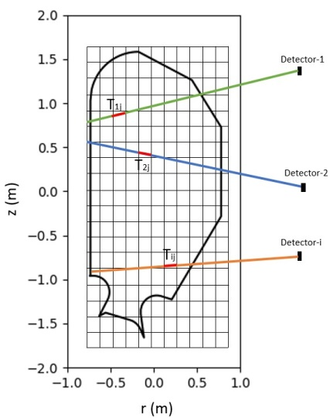
A pixel-based approach was chosen to evaluate the optimal design for reconstructing X-ray and UV radiation in the DTT tokamak. The region to be reconstructed was divided into a grid of n_{pixel} = n_{x}×n_{y} small rectangular pixels to achieve a constant emissivity, g, in each of them. The integral equation of the brightness was discretized through the relation:
Figure 2 The pixel grid layout used for tomographic reconstruction of the DTT tokamak, with a matrix element Tij highlighted to represent the weight of the i-th line of sight in the j-th pixel.
$$f_{i}= \sum_{j=1}^{n_{pixel}}{T_{ij}g_{j}}$$
Here, T_{ij} is a n_{LoS}×n_{pixel} matrix that contains the weight of the LoS in each pixel, which is determined by the length of the i-th line-of-sight (LoS) in the j-th pixel, as shown in Figure 2. The fundamental indeterminacy of tomographic reconstruction can result in the problem being solved in an infinite number of ways, and a priori conditions are generally introduced to minimize errors in the reconstruction process. One option uses the minimization of χ² with the Tikhonov regularization matrix H = Γᵀ · Γ [Anton et al., 1996]. The minimization equation is:
φ = χ2 + λ $g$ ᵀ H g Tᵀ,
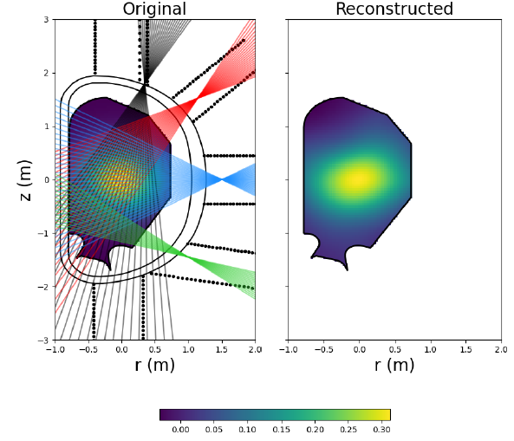
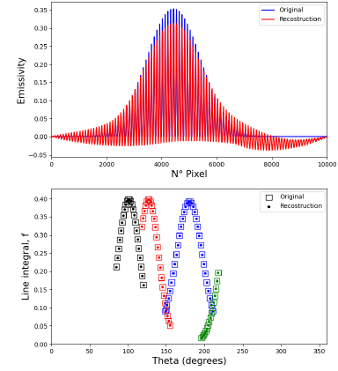
and the reconstructed emissivity is given by: $g_{meas}= {(T \text{ᵀ}\text{ · T + }\text{λ}\text{H)}}^{-1}$· T $\text{ᵀ}$ · $f_{meas}$. The reconstructed emissivity is the parameter that determines whether the regularization used is correct and, therefore, whether the reconstruction algorithm works effectively.
Figure 3 Comparison of the original and reconstructed data for the Gaussian phantom, line integral along the LoS, and emissivity as a function of pixels using a matrix of 100 x 100 pixel and 96 LoS.

- Tomography diagnostic lay-out
The tomography system will be installed in one sector of the DTT tokamak, provided with 4 ports (a fifth one, at the bottom, is essentially blind); the space has to be shared with other diagnostics, in particular the bolometry system, and other auxiliary systems such as cooling pipes, therefore the most compact design is highly desirable. In order to optimize the detectors spatial distribution and their number, a Python software was developed to determine the quality of the reconstructed images for different detector configurations. The goal was to reconstruct, by means of the inversion techniques described in the previous section, a two-dimensional Gaussian function centered at the origin defined by the equation:
$f\left(x,y\right)$ = $\frac{1}{2πσ^{2}}e^{- \frac{x^{2}+y^{2}}{2σ^{2}}}$
In this study, the width of the emission profile σ was set to 0.45, to simulate the broad emission to be expected in DTT. For this phantom type, the regularization matrix used is the gradient matrix. Initial tests were conducted to determine the best compromise between computational speed and image resolution, with 96 detectors and reasonable viewing angles (see Table I). The best results were obtained using an array of 100 x 100 pixel. Further tests were carried out to determine the minimum number of lines required for a good reconstruction while using the least possible number of devices. It was found that a reconstruction made with more than 100 LoS does not yield significant improvements, while lower number of LoS steadily degrade the quality of the reconstructed image, thus confirming the validity of the initial choice. The reconstruction shown in Figure 1Figure 3 is very similar to the original one, but increasing the number of nodes can further improve both spatial coverage and accuracy of the emissivity reconstruction in the peripheral regions. Figure 4 shows a reconstruction of the Gaussian phantom performed with 96 lines of sight, doubling the number of nodes in ports 2 and 3 and
Table I. Distribution of detectors in each port for the initial configuration of Figure 3 and that of Figure 4
Port # | # LoS | Opening Angle (°) | # LoS | Opening Angle (°)
1 | 24 | 35 | 24 | 35
2 | 24 | 37 | 12 | 30
 |  |  | 12 | 38
3 | 32 | 62 | 16 | 55
 |  |  | 16 | 45
4 | 16 | 22 | 16 | 55
 | Figure 3 |  | Figure 4

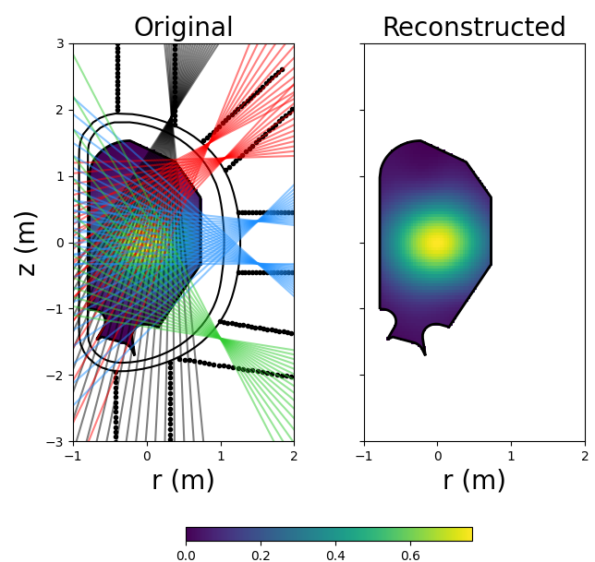

Figure 4 Same as Figure 3 but with two nodes in Ports 2 and 3, and a wider viewing angle in Port 4

increasing the opening angle of the node in port 4 (this can be problematic in practice). Additional tests, including more complex phantoms, are underway.

- CONCLUSIONS
The preliminary design of a Tomography diagnostic system for DTT is based on the use of thin, single crystal CVD diamond detectors. While conventional Si or CdTe diodes are not ruled out, their placement in the harsh environment of the machine would be challenging.
The detectors distribution is being driven by the results of tomographic reconstructions of simulated plasma emission profiles by means of a pixel-based code ad hoc developed that uses the minimization of χ² with the Tikhonov regularization. The number of pixels affects mostly the computational time, but a 100 x 100 matrix is adequate for a good reconstruction, with about 100 detectors. The other most important factors influencing the quality of the reconstruction have turned out to be the number of nodes and the aperture angles of the lines of sight.

- REFERENCES
Ambrosino, R., et al., (2021) Fus. Eng. & Des. 167: 112330
Angelone, M., et al., (2010) Nucl. Instrum. Methods A 623: 726
Anton, M., et al, (1996) Pl. Phys. Control. Fus 38.11: 1849
Bombarda, F., et al., (2021) Nucl. Fusion 61: 116004
Cesaroni, S., et al., (2022), 32nd SOFT, Dubrovnik (Croatia), Poster P-1.297
Mezi, L., et al., (2022) Il Nuovo Cimento 45 C 88
Pillon, M., et al., (2008) J. Appl. Phys. 104: 054513

