**Status of the Development and Testing of In-Vessel and ECH-Protection Components for the ITER Low-Field Side Reflectometer**

C.M. Muscatello1, J.P. Anderson1, R.L. Boivin1, F. Cometa1, R. Fair2, D.K. Finkenthal3, A. Forsman1, D. Fox1, R. Gar1, A. Gattuso1, G.J. Kramer2, M. LeSher1, F. Martinez1, S. Shirey1, A. Sirinelli4, D. Su1, K. Thackston1, A. Zolfaghari2

1General Atomics, San Diego, California, USA

2Princeton Plasma Physics Laboratory, Princeton, New Jersey, USA

3Palomar Scientific Instruments, San Marcos, California, USA

4ITER Organization, St Paul Lez Durance, France

E-mail of corresponding author: muscatello@fusion.gat.com

1. INTRODUCTION

The ITER Low-Field Side Reflectometer (LFSR) will provide critical information about the edge electron density, fluctuations, and plasma rotation. The plasma-facing antennas will be located in an equatorial port at the outboard midplane of the ITER tokamak. An end-to-end description and a system-wide performance assessment of LFSR have been given previously[1,2]. In addition, a performance assessment focused on in-vessel microwave components has been reported[3]. In this paper, new work and the current status of various microwave components of the in-vessel and ECH-protection sub-systems are discussed. Figure 1 is a CAD model of the vacuum portion of the LFSR transmission line. The components discussed in this paper are:

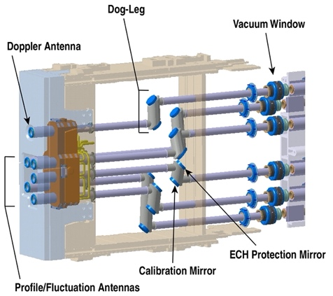

Figure 1. Front-end portion of the six LFSR transmission lines.

1. Antenna array: The array consists of 6 monostatic antennas for simultaneous profile, fluctuation, and Doppler measurements. The Doppler antenna is located at the top of the array, well above the midplane. The five lower antennas are for profile and fluctuation measurements and are positioned to accommodate for vertical displacement of the plasma. Performance of the reflectometer depends strongly on the antenna characteristics. Antenna performance, based on modeling and laboratory measurements, is presented in Section 2.

2. ECH protection mirror and monitor: Stray electron cyclotron heating (ECH) power at 170 GHz is a potential threat to the sensitive microwave electronics of the LFSR transceivers. The stray-ECH protection system for LFSR consists of both passive and active components. Passive diffraction gratings are the system’s first line of defense. Another layer of defense is a waveguide-integrated power monitor that shutters the diagnostic in the case of a significant stray-ECH event. Modeling and laboratory measurements of a diffraction grating and a conceptual design for the stray-power monitor are presented in Section 3.

3. Vacuum windows: Each transmission line includes a pair of dielectric windows as the vacuum boundary. Windows are a challenge for reflectometer systems because they cause strong spurious reflections, which can lead to measurable reduction to S/N. An anti-reflective solution compatible with ITER requirements has been developed and is discussed in Section 4.

1. ANTENNA ARRAY

The majority of the LFSR transmission line consists of 63.5-mm circular, corrugated waveguide which provides broadband, low-loss transmission of the signals[4]. The six antennas are formed from the open end of corrugated waveguide, which is a high-efficiency, high-gain solution for linearly-polarized launch and receive. The five lower antennas are designed for profile and fluctuation measurements and are oriented in horizontal planes for normal launch to the cutoff surface. They are positioned at four unique elevations to accommodate vertical displacement of the plasma. A Doppler antenna is located at the top of the array and also oriented in a horizontal plane with no poloidal tilt. Because of its elevation it launches obliquely to the cutoff surface, and it has a small toroidal tilt so that it also launches perpendicular to the magnetic field.

As shown in Figure 1, two non-standard mirrors are located in the first two miter bends after each antenna: ECH-protection mirror (diffraction grating) and phase-calibration mirror. The Doppler transmission line lacks the phase-calibration mirror. Antenna pattern measurements at the LFSR test stand were conducted to assess the mode conversion by these non-standard mirrors installed adjacent to the antenna. Measurements with two configurations of the dog-leg mirrors were compared: 1) baseline with standard, flat mirrors and 2) diffraction grating and phase calibration mirror. Antenna patterns for 55 GHz, 120 GHz and 160 GHz are shown in Figure 2(a-c) for Configuration 2 at three different distances from the antenna. The patterns are qualitatively similar for both cases, and low sideband power levels are observed, at or below -20 dB. The effect of the diffraction grating and calibration mirror on the waveguide mode content is quantified with a phase retrieval algorithm using the intensity data collected at each plane from the antenna. The phase retrieval algorithm used here is a combination of an iterative technique[5] and a numerical approach for analyzing beam propagation characteristics[6]. The diffraction grating and calibration mirror cause a small amount of mode conversion compared to standard mirrors. The amount of additional mode conversion increases with frequency, but only up to about 3% smaller HE11 power fraction at 160 GHz.

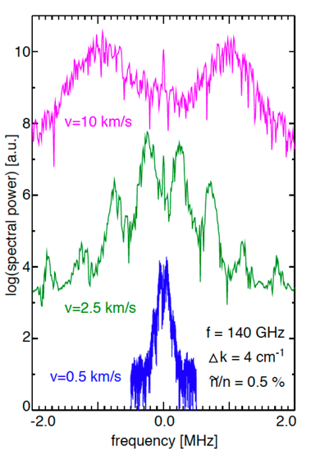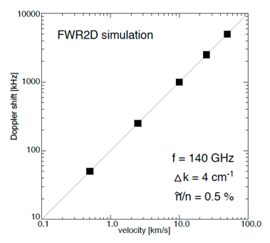

Figure 3. (a) Spectra from FWR2D for rotation velocities of 0.5 km/s, 2.5 km/s, 10 km/s. (b) Doppler shift of m=1 component vs. velocity.

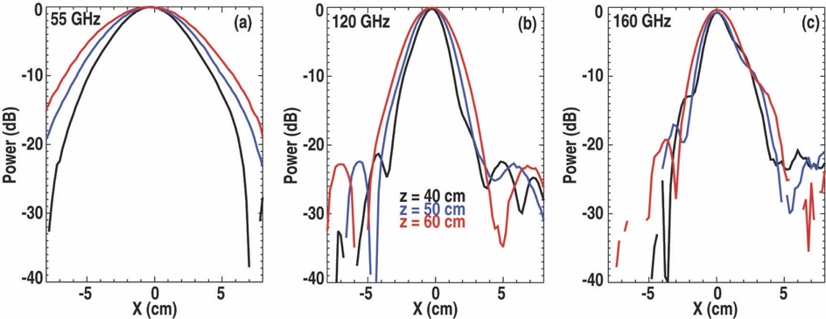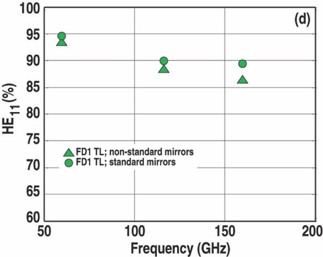

Figure 2. Antenna patterns at 40, 50, and 60 cm from the antenna for (a)55 GHz, (b)120 GHz, and (c)160 GHz. (d) Power fraction in the HE11 mode at the waveguide output.

The position and physical orientation of the Doppler antenna were designed to optimize its sensitivity to 𝑘⊥ and to maximize the coupled back-scatter, all while staying within the space constraints of the port. The antenna is positioned in a horizontal plane about 1 m above the midplane of the vessel, which is about 50 cm above the nominal midplane of the plasma. To compensate for the ~18 pitch angle of the magnetic field, the antenna is rotated toroidally by 1.5. With this toroidal rotation, the launch beam is almost perpendicular to the magnetic field. With this orientation, the Doppler system is sensitive to 𝑘⊥ = 8 cm-1 at 150 GHz, and 𝑘⊥ = 4 cm-1 at 75 GHz. The FWR2D code was used to verify that these wavenumbers are sufficient for meeting the measurement requirements. Profiles of a full-field (15 MA/5.4 T) ITER H-mode plasma were used. Broadband density fluctuations were generated uniformly over the plasma volume with a radial/poloidal wavenumber distribution centered at 𝑘𝑟 = 𝑘𝜃= 0 cm-1 and a spread of Δ𝑘𝑟 = Δ𝑘𝜃= 4 cm-1. The perpendicular group velocity was scanned over a range of 0.5 – 50 km/s (comparable to the measurement requirement of 1 – 50 km/s). With 140 GHz X-mode launch, fluctuation spectra with velocities of 0.5 km/s, 2.5 km/s, and 10 km/s are shown in Figure 3(a). The spectral reflection at DC (zero Doppler shift) is seen in each spectrum, and the Doppler peaks are well resolved even for the lowest simulated velocity. The Doppler shift for the |m| = 1 diffraction order for the 0.5 km/s case is 50 kHz. For the minimum measurement requirement of 1 km/s, the Doppler shift is ~ 100 kHz. The frequencies of the |m| = 1 peaks are plotted as a function of rotation velocity as shown in Figure 3(b), and the relationship is linear as expected. As for the upper bound of the measurement requirement, a perpendicular velocity of 50 km/s produces a Doppler shift of ~ 5 MHz, which is well within standard analog-to-digital converter (ADC) bandwidth.

1. ECH PROTECTION

High-power electron cyclotron heating (ECH) operating at 170 GHz is a potential threat to the sensitive back-end microwave electronics of the LFSR system. There are two ECH scenarios of concern to LFSR: 1) Breakdown assist: Up to 10 kW (70 dBm) of O-mode polarized power can couple into the LFSR transmission line for 5 seconds at the start of a discharge, and 2) Plasma heating: Up to 1 kW (60 dBm) of X-mode polarized power can couple into the LFSR transmission line for as much as several hundred seconds. Due to the potential for high-power levels of stray ECH reaching the LFSR transceivers, a robust protection system is needed. The LFSR protection system consists of both passive and active components, which are the blue elements of the schematic in Figure 4. The passive protection components provide the first line of defense and these consist of 170-GHz diffraction gratings integrated into miter bends; they are located in the vacuum and port cell regions. The active protection components shutter the back-end electronics in the event of sufficiently high power and these consist of a stray-ECH sensor, corrugated-waveguide switch, and fast switch; they are all located in the diagnostic hall.



Figure 4. Basic system-wide schematic of LFSR. The components involved in the ECH protection system are shown in blue.

Two diffraction gratings are installed within each transmission line. Combined, the two orthogonally-oriented gratings protect against both X- and O-mode stray ECH. The insertion loss (S21) of the diffraction grating was quantified at the LFSR test facility, and the measurement result is shown in Figure 5. Up to 160 GHz, there is negligible loss (much less than 1 dB), and the grating acts like a standard mirror. At LFSR’s highest operating frequency of 165 GHz, there is an increase in loss (about 5 dB). At 170 GHz there is strong rejection, indicated by the sharp drop in transmission at about -20 dB. Based on these results, the diffraction grating is an effective passive protection mechanism against 170-GHz ECH.

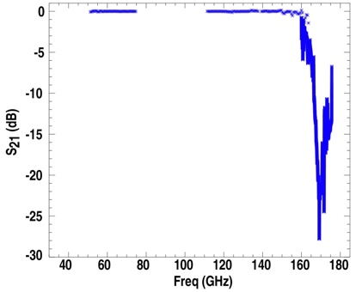

Figure 5. Insertion loss of 170-GHz diffraction grating.

Even with 20 dB of protection from the diffraction gratings, up to 100 W (50 dBm) can transmit to the diagnostic hall where the sensitive microwave electronics are located. These components have a damage threshold of about 10 dBm, so a fast-response, active protection system is also incorporated. A stray-ECH sensor will be installed in miter bends just before the waveguide switches (see Figure 4). It must detect mW power levels and activate the fast switch and waveguide switch when the power is over threshold. A key feature of the ECH sensor is a leaky mirror that passes a small fraction of 170 GHz for all incident polarizations. The mirror must not significantly impact the LFSR signal over the frequency range of 30 – 165 GHz. A similar power-monitoring approach for high-power transmission[8] is being pursued for LFSR. A CAD rendering is shown in Figure 6. The mirror consists of two rows of circular holes to couple a small fraction of 170-GHz power into waveguides that direct the power to commercial amplitude detectors. COMSOL results of this leaky-mirror design indicate the power coupling is sufficient to detect the expected range of incident stray-ECH power. Furthermore, the simulation results indicate the design is compatible with arbitrary polarization. Prototype fabrication and test verifications are currently ongoing.

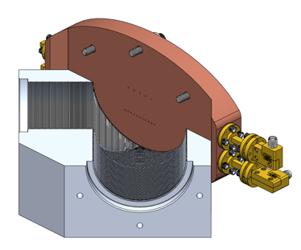

Figure 6. Miter-bend integrated stray-ECH sensor.

1. VACUUM WINDOWS

Windows are a challenge for reflectometer systems because they generally cause strong spurious reflections. These unwanted reflections can lead to measurable reduction in S/N and clutter in the FMCW signals. In ITER, two windows are required at the vacuum boundary for redundancy. In addition, two secondary confinement barriers are required as a safety measure to prevent tritium ingress in an accident event. This unprecedented number of windows required for the transmission line is a result of the safety standards for such nuclear facilities. Fusion power plants will impose even stricter requirements, necessitating innovative diagnostic solutions for signal transmission.

Anti-reflective (AR) coatings are a very effective way to reduce reflections and interference. Multi-layered dielectric coatings can provide very broadband improvement[9], but these coatings are not generally vacuum compatible and would not withstand the nuclear and thermal loads in ITER. An alternative approach is being considered for the LFSR windows involving metasurfaces. An important feature of this design is that the metasurface is fabricated onto the surface of two quartz wafers that are bonded to both sides of the quartz substrate. The substrate forms the structural component of the window, and the adhesive material used for bonding meets ITER requirements. Optimization modelling of the surface structure was performed with COMSOL. Preliminary measurements are available for a partial window assembly, which consists of an AR wafer bonded to one side of the substrate. Results are shown in Figure 7 for the partial AR assembly. Agreement is excellent between the measured and simulated return loss (S11) for both the uncoated substrate and partial AR assembly. With a complete window assembly (both sides coated), modeling predicts an additional 5-dB reduction of S11 at 110 GHz, as well as a significant improvement over the full frequency range. Manufacturing development is ongoing, and measurement results with the complete assembly are forthcoming.

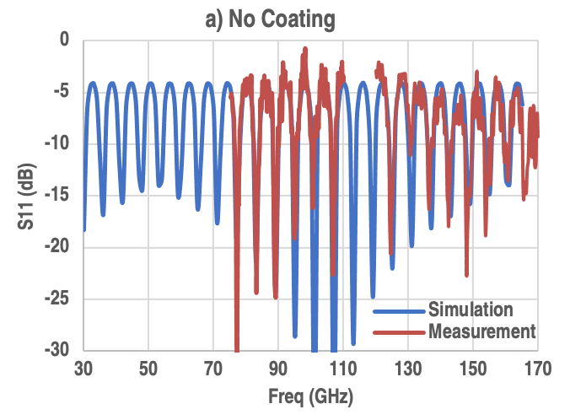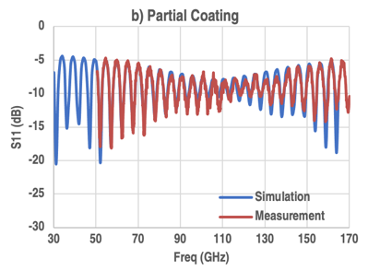

Figure 7. Return loss (S11) for (a) quartz substrate without AR coating and (b) with partial coating.

1. REFERENCES

[1] Muscatello C M, et al., Design overview of the low-field side reflectometer for ITER Proceedings of the 14th International Reflectometry Workshop (Lausanne, Switzerland) p O.113, 2019.

[2] Muscatello C M, et al., Nucl. Fusion **60** 066005, 2020.

[3] Muscatello C M, et al., Rev. Sci. Instrum. **92** 33524, 2021.

[4] Doane J L, Fusion Sci. Technol. **53** 159–73, 2008.

[5] Denison D R, IEEE Trans. Plasma Sci. **27** 512–9, 1999.

[6] Anderson J P, et al., IEEE Trans. Microw. Theory Tech. **50** 1526–35, 2002.

[7] Khayrutdinov R R and Lukash V E, J. Comput. Phys. **109** 193–201, 1993.

[8] Doane J, et al., Fusion Eng. Des. **93** 1–8, 2015.

[9] Nadolski A, et al., Millimeter, Submillimeter, and Far-Infrared Detectors and Instrumentation for Astronomy IX vol 10708, ed J Zmuidzinas and J-R Gao (SPIE) pp 719–31, 2018.

1. ACKNOWLEDGMENT[1]*

This work is supported by US DOE Contract No. DE-AC02-09CH11466. All US activities are managed by the US ITER Project Office, hosted by Oak Ridge National Laboratory with partner labs Princeton Plasma Physics Laboratory and Savannah River National Laboratory. The project is being accomplished through a collaboration of DOE Laboratories, universities and industry. The views and opinions expressed herein do not necessarily reflect those of the ITER Organization.

1. * DISCLAIMER: This report was prepared as an account of work sponsored by an agency of the United States Government. Neither the United States Government nor any agency thereof, nor any of their employees, makes any warranty, express or implied, or assumes any legal liability or responsibility for the accuracy, completeness, or usefulness of any information, apparatus, product, or process disclosed, or represents that its use would not infringe privately owned rights. Reference herein to any specific commercial product, process, or service by trade name, trademark, manufacturer, or otherwise, does not necessarily constitute or imply its endorsement, recommendation, or favoring by the United States Government or any agency thereof. The views and opinions of authors expressed herein do not necessarily state or reflect those of the United States Government or any agency thereof.