CONCEPTUAL DESIGN OF VISIBLE SPECTROSCOPY DIAGNOSTICS FOR DTT
A. Belpane^{1,2}, L. Carraro^{1,3}, A. Fassina⁵, M. Cavedon⁴, L. Senni⁵

- Consorzio RFX (CNR, ENEA, INFN, Università di Padova, Acciaierie Venete SpA), Corso Stati Uniti 4, 35127 Padova, Italy
- Department of Economics, Engineering, Society and Business Organization, University of Tuscia, Largo dell’Università, 01100 Viterbo, Italy;
- CNR-ISTP Padova, Italy
- Dipartimento di Fisica “G. Occhialini”, Università di Milano-Bicocca, 20126 Milano, Italy
- ENEA, Fusion and Nuclear Safety Department, 00044 Frascati, Italy
Email (andrea.belpane@igi.cnr.it)

ABSTRACT

The project of the diagnostics for the Z_{eff} radial profile measurement and for the divertor visible imaging spectroscopy, designed for the new tokamak DDT (Divertor Tokamak Test), is presented. To deal with the geometrical and functional constrains of DTT and to minimize the diagnostics volume inside the access pipe, an integrated and compact solution hosting the two systems has been proposed. The Z_{eff} radial profile will be evaluated from the Bremsstrahlung radiation measurement in the visible spectral range, acquiring light along ten Lines of Sight (LoS) in the upper part of the poloidal plan. The plasma emission will be focused on optical fibers, which will carry it to the spectroscopy laboratory. A second equipment, with a single toroidal LoS crossing the plasma center and laying on the equatorial plane, will measure the average Z_{eff} on a longer path. The divertor imaging system is designed to measure impurity and main gas influxes, to monitor the plasma position and kinetics of impurities, and to follow the plasma detachment evolution. The project aims at obtaining the maximum coverage of the divertor region. The collected light can be shared among different spectrometers and interferential filter devices placed outside the torus hall to easily change their setup. The system is composed of two endoscopes, an upper and a lower one, allowing a more perpendicular and a more tangential view of the divertor.

- INTRODUCTION

In the roadmap of the European program toward nuclear fusion (EuroFusion, 2018), one of the most critical challenges is to design an adequate power exhaust solution that can work in the harsh environment of the Demonstration Fusion Power Plant (DEMO). In this context, the new Italian project DTT (Divertor Tokamak Test) (Ambrosino, 2021), which will be built at ENEA Frascati research center, near Rome, is meant to investigate alternative divertor solutions to optimize the configuration for DEMO. To fulfill this scientific goal the device will be equipped with a set of diagnostics specifically dedicated to the study of the edge and divertor regions, focusing on impurity level, thermal characterization, plasma detachment, degree of enrichment of impurities, level of helium compression and power exhaust (Albanese,2017). With these goals, during the first plasma operation, DTT will be equipped with a first group of machine and plasma diagnostics, the so-called DAY0 systems (Polli, 2022), of which the diagnostics presented in this work are part.

To deal with the geometrical and functional constrains of DTT (cryostat presence) and to minimize the diagnostics volume inside the access pipe, an integrated and compact solution hosting four spectroscopy systems has been proposed:

- A multi-chords diagnostic to evaluate Z_{eff} profiles on the poloidal plane fortified with a robust measurement of the average Z_{eff} along a toroidal LoS (Line of Sight)
- two imaging spectroscopy diagnostics aiming at measuring the impurity and main gas influx from the divertor plasma facing components (PFC), and at spectroscopically investigating the divertor region to monitor detachment phenomena.

- EFFECTIVE CHARGE RADIAL PROFILE

The first system is a multi-chords diagnostic consisting of 11 telescopes that collect the emission from the plasma and then relay it through fibers to a laboratory room adjacent the Torus Hall. The system is subdivided in two sub-systems: 10 telescopes on the poloidal plane (see Figure 1.a) and the 11th with a toroidal view on the equatorial plane shown in Figure 1.b. Both subsystems use interferential filters centered at 523,5 nm ± 0,5 nm, a line-free spectral region to measure the Bremsstrahlung continuum. Main gas and impurity influxes could also be measured, with this system, adding filters and splitting the light directly in the laboratory.

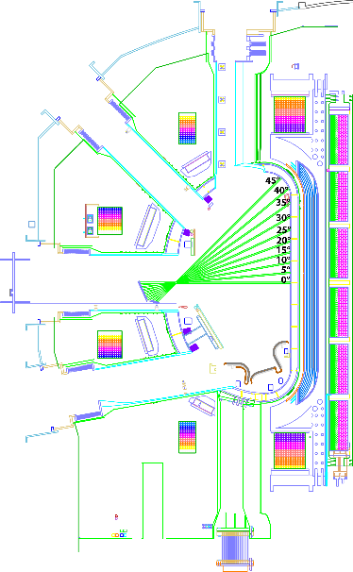  a) | b)
Figure 1 - Effective charge lines of sigh: a) tens lines of sight on the poloidal plane in the upper part of the vacuum vessel; b) toroidal line of sight on the equatorial plane

Figure 1.a shows the 10 LoS that cover the upper part of the poloidal plane thus avoiding the strong radiation from the divertor region, which can contaminate the Bremsstrahlung spectrum. Dumps will be inserted where the Z_{eff} LoS hits the internal first wall (on the high field side) in order to minimize reflection. The second Z_{eff} subsystem is made up of a single telescope that acquires emission along a single line of sight on the equatorial plane (orange line in Figure 1). This toroidal LoS, crossing the plasma core for a longer path, allows to minimize contamination by the plasma edge emission, providing a more robust evaluation of the plasma core Z_{eff}. As for the poloidal Z_{eff,} the reflections are minimized by pointing the LoS inside a port.
The harsh environment prevents the usage of a window close to the plasma; therefore, a mirror-based system to bring the emission outside the vessel to the telescopes located nearby the cryostat has been designed, as can be seen in Figure 2. The mirrors have a clearance optical diameter allowing the alignment of the optical system through the telescopes’ movement.

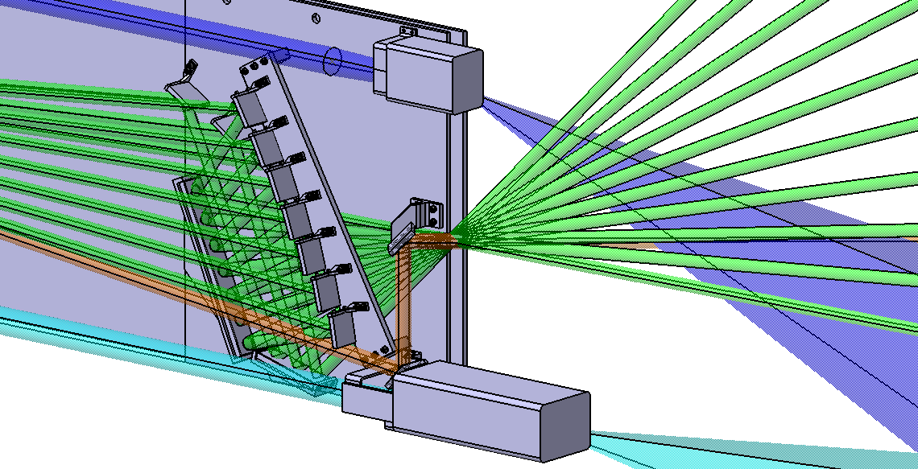
Figure 2 - Overview of the diagnostic
- DIVERTOR IMAGING SPECTROSCOPY

This sub-system aims at measuring the impurity and main gas influx from the plasma facing components (PFC), at spectroscopically investigating the divertor region, and at monitoring the detachment. The system is composed of two endoscopes that drive the emission outside the torus. The upper view, as reported in Figure 3.b, observes the divertor from a sloped view to see the divertor throats, (dark blue beam in Figure 2 and Figure 3) whereas the second one (light blue beam)), indicated as a lower view, has a more tangential, but wider vertical view for monitoring the detachment front movement. The spectral region of interest is 350-800 nm in order to monitor the ionization front movement and detachment onset, evolution and settlement.

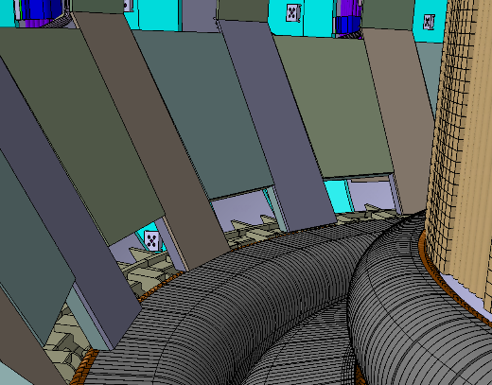  a) | 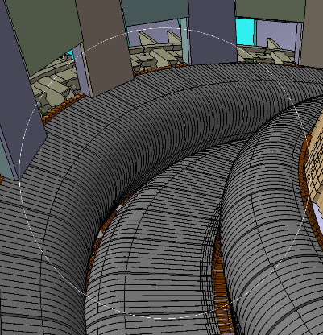  b) | 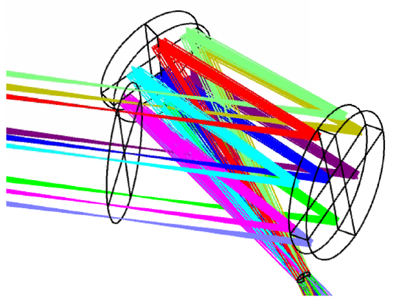  c)
Figure 3 - a) tangential view of the divertor region; b) vertical view of the divetor; c) ray tracing simulation of the mirror installed inside the optical head

In Figure 2 it can be seen that both systems are composed by similar structures (blue and light blue beams). Both heads are made of a metallic box that protects the optical elements: two mirrors, M1 flat, M2 parabolic (f=1993mm; k=-1) with an optical diameter of 50 mm allowing a spatial resolution of ~ 1 cm. The heads will host a shutter system, to protect the mirrors during wall conditioning operations, which will be equipped with a cooling system to cope with the intense thermal loads from the plasma.

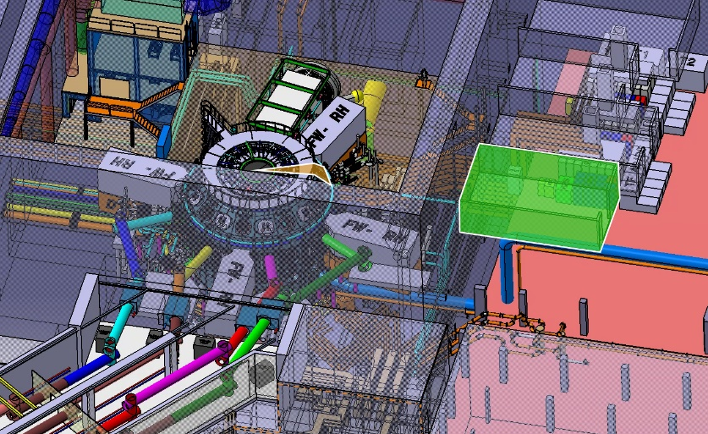
Figure 4 - Ray path from the torus to the laboratory

The possibility of placing the spectroscopic instruments operating in the visible range outside the torus hall will be pursued, in order to share light among different spectrometers and interferential filter devices and to allow easy access to the instruments’ setup. To pursue this goal the emission from the torus must be relayed to the laboratory, along a path about 25 m long. To avoid chromatic aberrations a mirror-based relay system is being designed.

- CONCLUSION AND FUTURE WORK

In this work, the conceptual design of the main visible spectroscopy diagnostic systems for DTT was presented. A solution that ensures the performance target of different spectroscopy systems and, at the same time, fits the geometrical constrains of the device port has been found. The space and the form adopted take into account the harsh environment, in which the system will work. The next steps to finalize the diagnostic include the support components that must be installed in the torus hall, the design of the cooling system and of the mirror-based relay system to bring the divertor image from the vessel to the laboratory.

- REFERENCES

EuroFusion. (2018) “European Research Roadmap to the Realization of Fusion Energy”.URL: https://euro-fusion.org/eurofusion/roadmap/
R. Albanese, et al. (2017) “Diagnostics, data acquisition and control of the divertor test tokamak experiment”. In: Fusion Engineering and Design 122. DOI: http://dx.doi.org/10.1016/j.fusengdes.2017.05.118
R. Ambrosino, et al. (2021) “DTT - Divertor Tokamak Test facility: A testbed for DEMO”. In: Fusion Engineering and Design 167. DOI: https://doi.org/10.1016/j.fusengdes.2021.112330
G. M. Polli, et al. (2022) "Status of design and procurement activities in DTT tokamak project area". In: IEEE 21st Mediterranean Electrotechnical Conference 477-482. DOI: 10.1109/MELECON53508.2022.9843123

