REAL-TIME ELECTRON TEMPERATURE AND DENSITY MEASUREMENT BY THOMSON SCATTERING

FOR PLASMA CONTROL ON LHD

Funaba, H¹, Yamada, I¹, Yasuhara, R¹, Kenmochi, N¹, Morishita, Y²,
Murakami, S², Lee, J-H³, Nakanishi, H¹, Osakabe, M¹

¹National Institute for Fusion Science, National Institutes of Natural Sciences,
Toki, Gifu 509-5292, Japan
²Department of Nuclear Engineering, Kyoto University, Nishikyo, Kyoto, 615-8540, Japan
³Korea Institute of Fusion Energy, Daejeon 34133, Korea
funaba.hisamichi@nifs.ac.jp

Abstract
Real-time measurement of the spatial profiles of the electron temperature and density is required for the Thomson scattering system on the Large Helical Device. The real-time data processing is made by the new fast digitizers and the RTRetrieve data acquisition system. Although the calculation time of the electron temperature and density is almost 18 ms, the total delay time from the laser pulse to the output of the results is up to 100 ms. This delay time is enough for the ASTI system, which is a data assimilation system for integrated transport simulation of fusion plasma.

1. INTRODUCTION
Ral-time information of the electron temperature, T_{e}, and the electron density, n_{e}, profiles can be used for evaluating or controlling the heating profiles, the magnetic configurations, the divertor detachment, and so on (Laggner, et al., 2019, Eldon, et al., 2017). For example, in the real-time Thomson scattering system on KSTAR (Lee S-J, et al., 2020, Lee S-J, et al., 2021, Lee J-H, et al., 2023), T_{e} data are provided for the PCS (Plasma Control System). The GPU system is used for the data processing with Fourier transform and T_{e} calculation by the neural network. Figure 1 shows a schematic diagram of a real-time measurement by the Thomson scattering system. The scattered light from the plasma is dispersed by the polychromators and the signals are acquired by the fast digitizers. The data are transferred from the acquisition PC to the data analysis PC just after the acquisition of the signals. The calculation of T_{e} and n_{e} are made in real-time on the analysis PC.
The real-time measurement of the spatial profiles of T_{e}, and n_{e} is required for the Thomson scattering diagnostics on the Large Helical Device (LHD) (Narihara, et al., 2001, Yamada, et al., 2010) by the ASTI system (Assimilation System for Toroidal plasma Integrated simulation), which is developed in Kyoto University (Morishita, et al., 2022). The experiments of the plasma control by ASTI started on LHD in 2022. It is considered that the following controls become possible by the ASTI system: (1) Real-time plasma control with the data from multiple diagnostics, (2) Prediction of some phenomena (e.g., radiation collapse etc.) with the modeling of them.
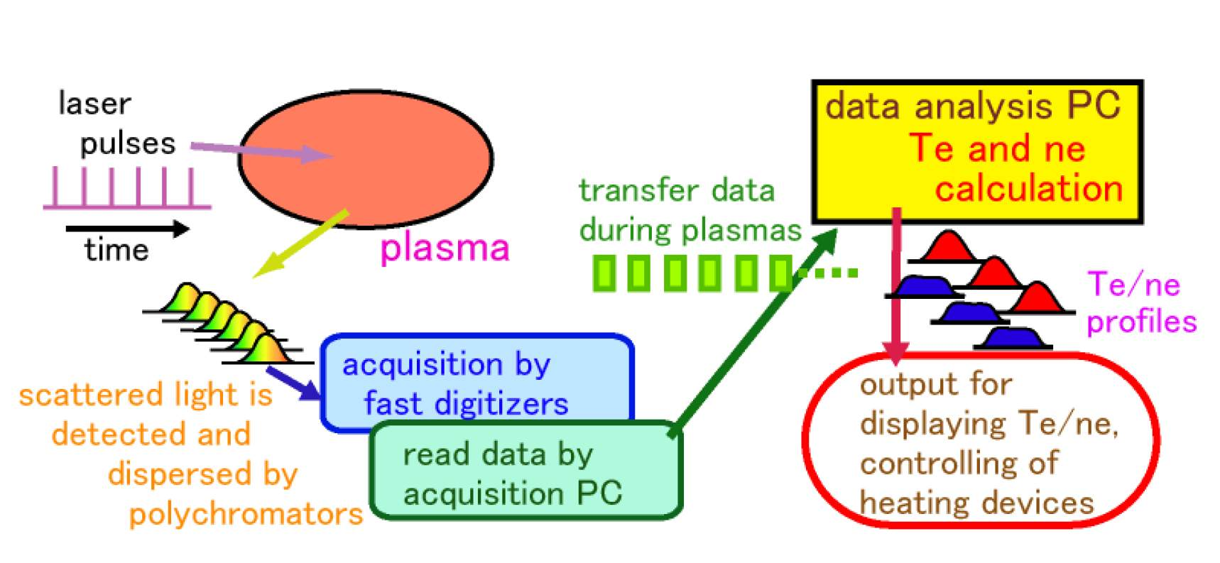
Figure 1. A schematic diagram of a real-time measurement by the Thomson scattering system.
In this study, it is intended to read the Thomson scattering signals and to calculate T_{e} and n_{e} in a few tens of milliseconds during plasma discharges in order to predict and control the temporal development of the plasma parameters, such as T_{e} and n_{e}, through the transport simulation by the ASTI system. The data processing and calculation time are recorded in detail and adjusted for the real-time measurement.
Section 2 describes the systems for the real-time data acquisition and the analysis system. The results of the real-time measurement are shown in Sec. 3. Section 4 is a conclusion.

2. MATERIALS AND METHODS
Although the LHD Thomson scattering system has 144 spatial points for measurement, signals from 70 points are used for the real-time measurement. Fast digitizers of the switched-capacitor type (TechnoAP APV85G32L), which obtain the fast signals with their time development, are used. These digitizers are installed for the Thomson scattering measurement with a high repetition rate laser of 20 kHz (Funaba, et al., 2022).
The data transmission process is shown in Fig. 2. The data are read by the analysis program through the RTRetrieve system (Nakanishi, et al., 2016). The data transferring starts by the command "RTCtransfer" and the data are stored in the memory of the analysis PC. The reading program reads the one channel data by the "RTCgetChannelData" command. The number of the data for one laser pulse is 32 channels times 12 digitizer boards. The usual, not dedicated, network is used for the data transfer between the acquisition PC and the analysis PC.
In the data analysis PC, the signals are integrated in time and T_{e} is calculated by the χ²-method. n_{e} is derivid with the calibration resulats of Raman scatterig.
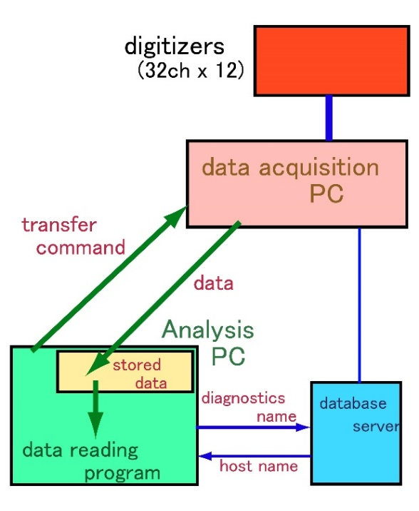
Figure 2. Real-time data acquisition by the RTRetrieve system (Nakanishi, et al., 2016) on LHD.

As shown in Fig. 3, the T_{e} and n_{e} profiles are transmitted to a vector engine server SX-Aurora TSUBASA in real-time by the socket communication and used as inputs of the ASTI system. The output of the ASTI system is used for the control of the plasmas by the heating devices. The control of the electron cyclotron heating (ECH) system is connected to this system at present. Since the ASTI system read the data in 10 Hz, the required delay time is within 100 ms at present. The input and output which are shown in the broken boxes in Fig. 2 are under planning and not installed.
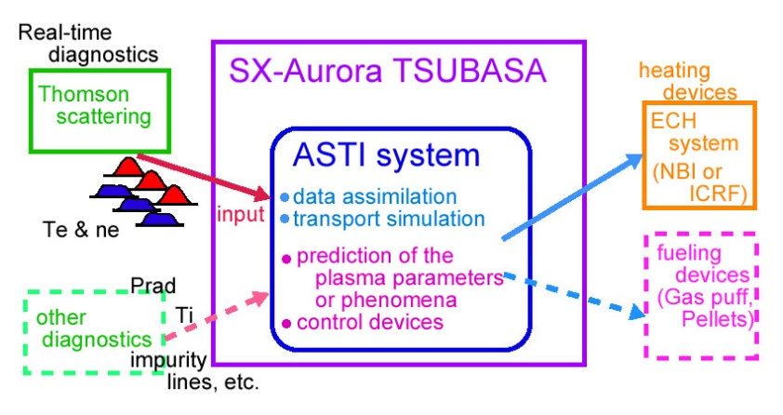
Figure 3. A schematic diagram of inputs and outputs in the ASTI system.
Inside the broken boxes are under planning.

3. RESULTS AND DISCUSSION
The real-time measurement by the Thomson scattering diagnostics was operated in the 10 Hz of the repetition frequency. Figure 4 shows an example of the real-time monitoring of the T_{e} and n_{e} profiles at t = 3.60 s. This picture was taken from a movie in which the real-time measurement during the LHD plasma of #183873 was recorded. The red and blue data show the T_{e} profile and the n_{e} profile, respectively. The camera images of the plasma at the same time are shown in the multi-screen display in the right side.

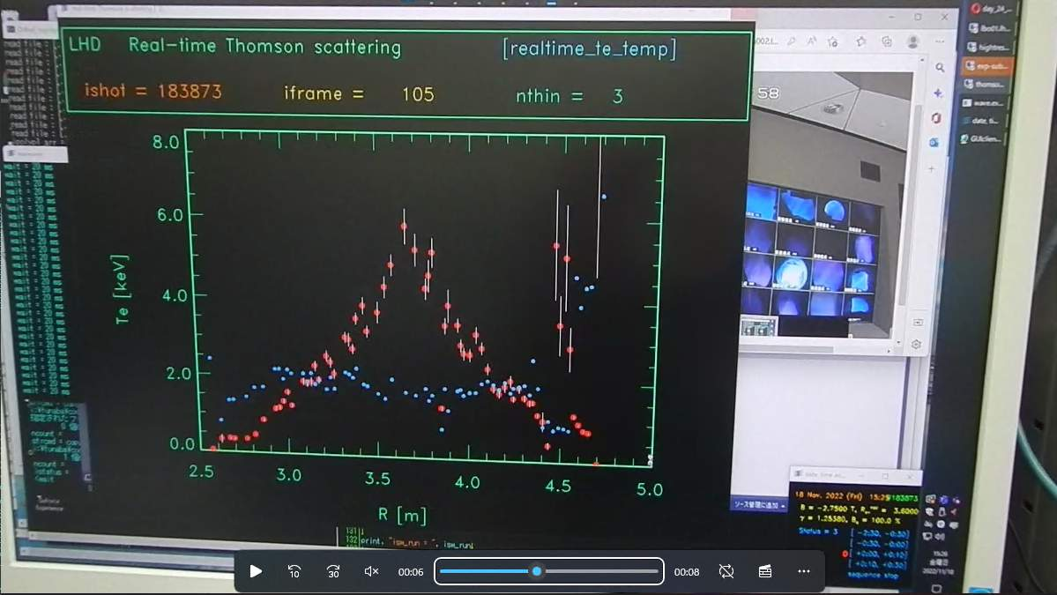
Figure 4. An Example of the real-time monitoring of the T_{e} and n_{e} profiles by the Thomson scattering diagnostics.

In order to evaluate the delay time from the laser pulse, t_{delay}, it is divided in three as follows.

t_{delay} = t_{d1} + t_{d2} + t_{d3} [1]
t_{d1} : Time between the laser pulse and reading of all data in the data analysis PC
t_{d2} : Calculation time in the data analysis PC
t_{d3} : Data transmission time between the data analysis PC and the plasma control system

The detailed timings of the calculation are recorded in a log-file as shown in Fig. 5. Timings are written at some of the red lines. The time from the start timing of the sequence (t = 0 s) and the time from the previous output are shon by "from start" and "passed" in these lines, respectively. The calculation time for T_{e} and n_{e} are 12 ms and 6 ms, respectively. Therefore, t_{d2} is 18 ms in this case. At the blue line, the process for the signals by the laser pulse at t = 5.7 s started. The first data are read after 33 ms. Almost all of the data are read within 1 ms since the data are stored in the memory of the analysis PC. However, waiting times of 15 - 33 ms are needed before reading a few signals of the data. The total reding time t_{d1} becomes about 70 ms. However, no accumulation of the delay time was observed.
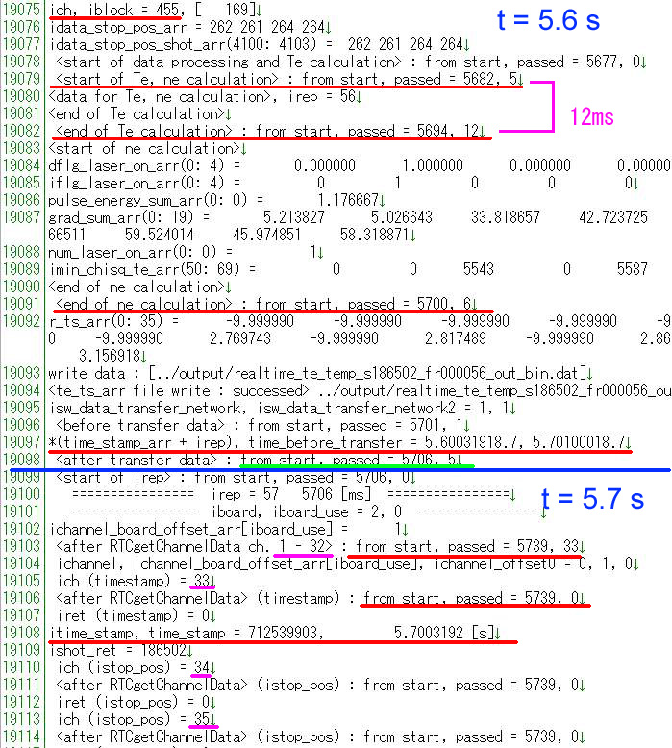
Figure 5. Texts from a log file of the real-time measurement program around t = 5.7 s.

4. CONCLUSION
The real-time Thomson scattering system started to operate and provide T_{e} and n_{e} profiles to the ASTI system with the repetition rate of 10 Hz and the delay time up to 100 ms. The delay time within 100 ms is enough for the ASTI operation at present. No accumulation of the delay time was found. The details of the delay time were evaluated. The data reading time is almost 70 ms and the calculation time is about 18 ms. The value of the data reading time seems to be long. In order to reduce this time, the multithreading will be applied for data reading by the RTRetrieve system.

ACKNOWLEDGMENT
The authors appreciate the assistance of the LABCOM group in NIFS. This work is supported partially by NIFS20ULHH005, NIFS22KIPT008, JSPS KAKENHI Grant Numbers 15KK02451, 21K13901 and 23H01162. This work is in cooperation with KFE-EN2101-12 with Ministry of Science and ICT under KFE R&D Program.

REFERENCES
Eldon, D, et al., (2017) Nucl. Fusion 57: 066039.
Funaba, H, et al., (2022) Sci. Rep. 12: 15112.
Laggner FM, et al., (2019) Rev. Sci. Instrum. 90: 043501.
Lee, S-J, et al., (2020) Fusion Eng. Des. 158: 111624.
Lee, S-J, et al., (2021) Fusion Eng. Des. 171: 112546.
Lee, J-H, et al., (2023) Fusion Eng. Des. 190: 113532.
Morishita, Y, et al., (2022) Comput. Phys. Commun. 274: 108287 .
Nakanishi, H, et al., (2016) IEEE Trans. Nucl. Sci. 63: 222.
Narihara, K, et al., (2001) Rev. Sci. Instrum. 72: 1122.
Yamada, I, et al., (2010) Fusion Sci. Tech. 58: 345.

