Status of the EUROfusion Enabling Research Project: Advances in real-time reflectometry plasma tracking, for next generation machines

F. da Silva¹, J. Santos¹, A. Silva¹, J. Ferreira¹, E. Ricardo¹, S. Heuraux², R. Sabot³, F. Clairet³, Y. Moudden³, G. De Masi⁴, R. Cavazzana⁴, G. Marchiori⁴, R. Bianchetti Morales⁵, P. R. Resende⁶, J. C. Abrantes⁶, R. Luís¹, Y. Nietiadi¹

¹Instituto de Plasmas e Fusão Nuclear, Instituto Superior Técnico, Lisbon, Portugal
²Institut Jean Lamour, Université de Lorraine, CNRS, F-54000 Nancy, France
³IRFM - CEA Cadarache, Saint-Paul-lez-Durance Cedex, France
⁴Consorzio RFX C.so. Stati Uniti,4, 35127 Padova, Italy
⁵UK Atomic Energy Authority/Culham Centre for Fusion, Oxfordshire, United Kingdom
⁶proMetheus, Instituto Politécnico de Viana do Castelo, Viana do Castelo, Portugal
tanatos@ipfn.tecnico.ulisboa.pt

Abstract
We have put forward an Enabling Research Project (EnR) to contribute to the conceptualization of a reflectometry system able to provide control inputs not only in steady-state operation (flattop) but also during the initial stage of the discharge (ramp-up phase), paving the away to the use of plasma position reflectometry in next next-generation machines, such as DEMO. We propose an integrated approach involving different areas of research, such as the development of simulation codes and synthetic diagnostics, the development of new algorithms, synchronization between different reflectometer systems, and advances in reflectometry hardware, coming together coherently, in a forthcoming diagnostic. This paper shows the main issues addressed in this EnR and presents its status at the mid-term of the project.

- MOTIVATION AND OBJECTIVES
One of the major roles for expected for reflectometry in DEMO will be plasma positioning and shaping control, complementing or effectively substituting magnetic diagnostics. The first steps to achieve this goal have already been taken experimentally, theoretically, and with simulations (Santos, 2012) but a great amount of groundwork remains to be done. An EUROfusion Enabling Research Project (ENR-TEC.01.IST) was built involving a team of experts and developers of reflectometry systems in Europe aiming to tackle many of the still remaining open questions and come out with a coherent and unified approach allowing to implement a reflectometry system able to provide control inputs not only in steady-state operation (flattop) but also during the initial stage of the discharge (ramp-up phase). The objectives and associated outcomes are divided into two main branches with their own specificities and requiring different approaches: (i) The ability to track and monitor the position and shape of the plasma in the start-up phase of the discharge and also at its ramp-down phase; (ii) To improve the capabilities of operation in the stationary phase (flattop) in order to provide an accurate and precise substitute to the positioning magnetic diagnostics in real-time. An important issue that must be addressed is the synchronization between all reflectometers. An experimental validation on the tokamak WEST will prove the concepts of synchronizing several reflectometers sharing the same clock and synchronizing triggering events. The project also contemplates advances in hardware with a prototype of a compact coherent fast frequency sweeping radio frequency (RF) back-end being developed using commercial Monolithic Microwave Integrated Circuits (MMIC) with Direct Digital Synthesis (DDS), which allows for full control of the signal’s frequency and phase, both with very high precision and resolution.

- THE EFFORTS DURING THE FIRST HALF OF THE PROJECT
DEMO’s Plasma Position Reflectometry concept involves a set of poloidally distributed reflectometers (Marchiori, 2018). The final number of lines of sight (LOS) remains open and, at this point, the main restriction on the table are the waveguide accesses, which are limited and ultimately will determine how many antennas can face the plasma, see Figure 1-(a). Our proposal involves having the same hardware running with different modes of operation, see Figure 1-(b).
For the ramp-up, we propose an entirely new setup that will involve:
- Interferometry.
- Refractometry.
- Intensity refractometry.
For steady state, the hardware will work as normal PPR reflectometers. Note that, in D shaped machines, little or no experience is available in using reflectometers for plasma density profile measurements outside the equatorial position.

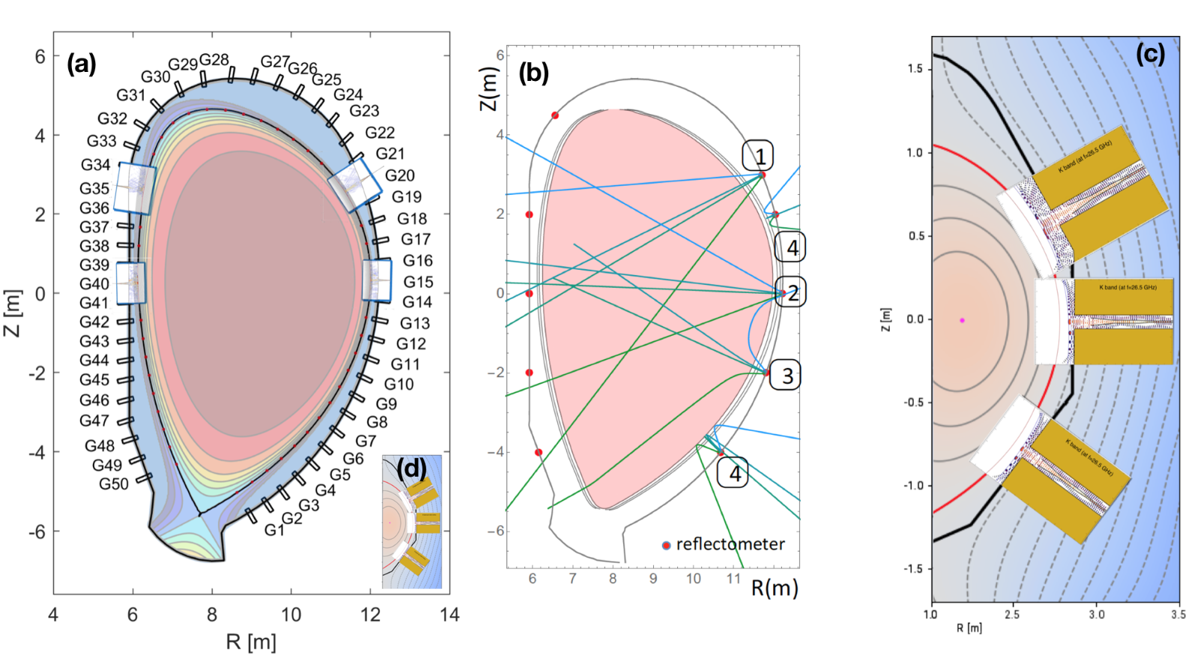
Figure 1. (a) Concept of DEMO PPR involves several reflectometry LOS placed poloidally around the machine; (b) For ramp-up, a new diagnostic concept is being developed. The PPR hardware will work as an interferometer (1), as a refractometer (2) or as an intensity refractometer (3) as well as the standard reflectometer operation mode (4); (c) shows the LSF PPR synthetic diagnostics probing a DTT SN plasma; and (d) allows to compare the dimensions of the DTT vessel against DEMO’s.

These goals involve developments in different fields, namely (i) Development of synthetic diagnostics [prepare DEMO and DTT density inputs for simulation codes, developments in FDTD codes, developments in the description of structures (antennas/waveguides/vessel walls)], developments in the description of plasma scenarios); (ii) Development of new algorithms (for steady state and ramp-up); (iii) Synchronization between different reflectometers (experimental validation on the tokamak WEST); (iv) Advances on reflectometry hardware (compact reflectometer prototype using MMIC with DDS signal generation); and (v) DTT as a possible testbed for DEMO (Synthetic diagnostics for simulation and algorithms, design of antennas for a possible PPR implementation).
At the beginning of the EnR, the code REFMUL3 entered the production stage and was added to the EnR codes’ toolkit, making 3D simulations available. REFMUL3 is a 3D parallel code with all field components included. It has a parallel hybrid implementation (OpenMP+MPI) with 3D domain decomposition, showing very good scaling behavior, and a XDMF/HDF5 compressed binary output (da Silva 2022). Within the EnR ameliorations have been added, a pitstop/restart file implementation, a VTK format output, and an ancillary CAD import pipeline, allowing an unprecedented description of the synthetic diagnostics (Santos, 2021).
DEMO steady state has been comprehensively studied in this first half on the enabling research and with advances made in algorithms for steady state (Ricardo, 2021). We will devote the reminder of the project to research solutions pertinent to the ramp-up concept, namely with the identification of the many operational cases possible and which operational model to use associated with the appropriated interpretative model.
On the hardware development front, two compact reflectometer prototype PCB boards were developed and built using MMIC with a back-end covering directly 10 to 20 GHz, which with full band frequency multipliers can be extended to 140 GHz. The initial tests performed with these prototypes were very encouraging with the back-end prototype generating full band signals exceeding 8 dBm, enough to drive external multipliers. All undesirable harmonics are 15 dBi below the desired output, in all frequency ranges (Silva, 2021). Testing the quadrature detector will follow. An important feature to be implemented is DDS signal generation.
Concerning Synchronization between different reflectometers, the experimental validation on the tokamak WEST started with successful laboratory tests. However, the tests in situ in real environmental conditions have been postponed due to the delay of the WEST experimental campaign.
Works on DTT have progressed well with a comprehensive assessment of a LFS PPR system made with 2D simulations done with REFMULF code, see Figure 1-(c), complemented with 3D ones, performed with REFMUL3. During the project, the possibility of having a PPR system installed at DTT became tangible with the hypothesis of one or two LOS in the High Field Side (HFS). The concept of this tentative HFS system is needed as soon as possible since its deployment includes the installation of the waveguide access embedded in the structure of the vessel. This shifted our efforts from the LFS to the HFS, in particular to the design of the antennas and their integration in the first wall. The space available is at a premium and had to be taken into consideration. Two types of antennas are being proposed, the first for a bistatic system, and the second for a monostatic one.

- STATUS OF THE WORK AT MID-TERM (27 SEPTEMBER 2022)
The status of the EnR Project at its midpoint is very encouraging with the vast majority of tasks either on schedule or completed, many of these with objectives surpassed. Further knowing that some of these tasks were not in the initial project proposal, but were rather late additions, one can vow for the good progress of the work. This can be confirmed in the following task accomplishment summary:
- Development of synthetic diagnostics
- DEMO and DTT density inputs for simulation codes - On schedule
- Developments in FDTD codes (+REMUL3) - Completed (surpassed objectives)
- Developments in the description of structures - Completed (surpassed objectives)
- Developments in the description of plasma scenarios - Completed (surpassed objectives)
- Development of new algorithms
- For steady-state - Completed
- For ramp-up - On schedule with work intensifying in the remainder of EnR
- Synchronization between different reflectometers
- An experimental validation on the tokamak WEST - Delayed
- Advances in reflectometry hardware
- Compact reflectometer prototype using MMIC with DDS signal generation - On schedule
- DTT as a possible testbed for DEMO
- Synthetic diagnostics for simulation and algorithms - On schedule
- Design of antennas for a possible PPR implementation - On schedule

So far, the EnR has produced some scientific output, two peer-reviewed publications and six communications to conferences and workshops. More publications are expected by the end of the project.

- RECENT WORK SINCE MID-TERM
Since these mid-term milestones work has progressed, namely the status of the experimental validation synchronisation of WEST reflectometers has picked up its pace, with the implementation and test of the trigger synchronisation for the C8 campaign (starting in October). Also, outside the synchronisation work, but still in the scope of the ENR project, some hardware developments for real-time reflectometry measurements on WEST have been achieved. It is planned for a Ph.D. student to start his work, closely linked to the EnR project objectives, under the supervision of one of its members, Y. Moudden.
In the sequence of Request to Advanced Computing Hubs support, REFMUL3 is being adapted to run on GPU HPCs using OpenMP offloading with promising preliminary results.
For DTT, the CAD wall embedding of the newly designed HFS antennas and its conversion to REFMUL3 input format is afoot with the first simulation results for the bistatic antenna design in vacuum finished. Also, a 3D-printed mock-up bistatic antenna was done and the laboratory tests are underway.
First full-wave support simulations, for validation of ray trace studies of ramp-up, have started and will intensify in the last run of the EnR project.

- ACKNOWLEDGMENT
This work has been carried out within the framework of the EUROfusion Consortium, funded by the European Union via the Euratom Research and Training Programme (Grant Agreement No 101052200—EUROfusion). The work has been carried out under the EUROfusion Enabling Research project ENR-TEC.01.IST. Views and opinions expressed are however those of the author(s) only and do not necessarily reflect those of the European Union or the European Commission. Neither the European Union nor the European Commission can be held responsible for them. IST activities also received financial support from Fundação para a Ciência e Tecnologia (FCT).
- REFERENCES
da Silva, F., Ricardo, E., Ferreira, J., Santos, J., Heuraux, S., Silva, A., et al. (2022). Benchmarking 2D against 3D FDTD codes for the assessment of the measurement performance of a low field side plasma position reflectometer applicable to IDTT. Journal of Instrumentation, 17(01), C01017. http://doi.org/10.1088/1748-0221/17/01/C01017.
Marchiori, G. et al. (2018). Study of a Plasma Boundary Reconstruction Method Based on Reflectometric Measurements for Control Purposes. IEEE Transactions on Plasma Science, vol. 46(5):1285-1290, http://doi.org/10.1109/TPS.2018.2797549.
Ricardo, E. A. (2021), Assessment of reflectometry diagnostics for DEMO, Doctaoral Thesis, Instituto Superior Tecnico, Universidade Tecnica de Lisboa.
Santos, J., Guimarãis, L., Zilker, M., Treutterer, W., Manso, M. and the ASDEX Upgrade Team (2012), Reflectometry-based plasma position feedback control demonstration at ASDEX Upgrade, Nuclear Fusion, 52:032003. http://doi.org/10.1088/0029-5515/52/3/032003.
Santos, J. M., Ricardo, E., da Silva, F. J., Ribeiro, T., Heuraux, S., and Silva, A. (2021). A 3D CAD model input pipeline for REFMUL3 full-wave FDTD 3D simulator. Journal of Instrumentation, 16(11), C11013. http://doi.org/10.1088/1748-0221/16/11/C11013.
Silva, A. et al (2021), FM-CW compact reflectometer using DDS signal generation, Journal of Instrumentation 16:C11005. https://dx.doi.org/10.1088/1748-0221/16/11/C11005.

