COHERENT XUV MULTISPECTRAL DIFFRACTION IMAGING IN

REFLECTION MODE AND PROSPECT IN DENSE PLASMA DIAGNOSTICS

E.P. Benis^{1,2}, S. Petrakis^{1,2}, A. Skoulakis¹, Y. Orfanos¹, N. Kortsalioudakis³, C. Balas³, D. Zouridis⁴, E. Pachos⁴, M. Bakarezos¹, V. Dimitriou¹, M. Tatarakis¹, and N.A. Papadogiannis¹

¹Institute of Plasma Physics and Lasers, Hellenic Mediterranean University Centre for Research & Innovation, 74100 Rethymno, Greece
²Department of Physics, University of Ioannina, 45110 Ioannina, Greece
³School of Electrical & Computer Engineering, Technical University of Crete, 73100 Chania, Greece
⁴IKNOWHOW (IKH), 340 Kifisias 116 Ave. Neo Psychiko, 15451 Athens, Greece
E-mail: mbenis@uoi.gr

Abstract
Current science and related technology of optical dynamic imaging in the nanoscale requires a spatiotemporal resolution offered by coherent ultrafast radiation with wavelengths reaching the x-ray region. Lensless coherent diffraction imaging is a powerful tool towards such studies, especially when used in reflection mode, appropriate for the characterization of micro- and nano-structures developed on surfaces, as well as for dense plasma diagnostics. In this article, we present the feasibility of multispectral coherent diffraction imaging in reflection mode in the extreme ultraviolet, demonstrating that features of the order of a few hundreds of nanometers can be resolved. The coherent extreme ultraviolet radiation used consists of a comb of high harmonics generated by near-infrared femtosecond laser pulses focused onto an atomic gas target, while the selection of specific extreme ultraviolet harmonics is performed by specially designed pairs of multilayer mirrors.

- INTRODUCTION
The spatiotemporal resolution of optical dynamic imaging depends on the wavelength and duration of the radiation in use. Current needs drive science and related technology towards its limits using ultrafast radiation with wavelengths reaching the x-ray region. To fully exploit the advantages of such small wavelengths, the radiation must be coherent. Ultrafast coherent XUV and x-ray radiation can be generated either by large and expensive synchrotrons and free-electron lasers, or by table-top systems via femtosecond (fs) laser high harmonics (HH) (Lewenstein et al., 1994). Lensless coherent diffraction imaging (CDI) has been proven as the favorable technique in the XUV and x-ray spectral regions (Sandberg et al., (2007), Zurch et al., (2014), Miao et al., (2015), Gardner et al., (2017)). Table-top HH systems are suitable for high quality ultrafast CDI, since the produced XUV radiation has high coherence and adequate intensity, while the ultrafast properties and phase front are preserved. Since XUV wavelengths have a very small penetration depth, CDI in reflection mode is required for the characterization of micro- and nano-structures developed on surfaces as well for dense plasma diagnostics, not applied to so far. Besides the high spatiotemporal resolution, CDI XUV HH systems offer a comb of wavelengths that can be utilized for multispectral imaging. In our recent article (Petrakis et al., 2022b), we have shown that the use of a combination of multilayer mirrors allows for the selection of specific wavelengths which have been used for XUV CDI in transmission mode. CDI in reflection mode has the added complexity that the XUV radiation must be incident onto the sample at grazing angles, for which the reflected diffraction energy is sufficiently large.
In this article, we present multispectral XUV CDI in reflection mode of the honeycomb structure of a commercially available multichannel plate (MCP), demonstrating that features of the order of a few hundreds of nanometers can be resolved. We have compared imaging results for three different wavelengths, namely 807 nm, 46.7 nm, and 32.2 nm. Whereas with the 807 nm wavelength the honeycomb structure features cannot be accurately resolved, the 32.2 nm is found to offer higher resolution than the 46.7 nm wavelength.

- MATERIALS AND METHODS
The optical layout of the XUV CDI experimental setup operating in reflection mode is shown in figure 1. The setup was designed and developed at IPPL-HMU (Clark et al., 2021), and was largely based on our XUV CDI setup in transmission geometry, described in detail in (Petrakis et al., 2022b). The coherent XUV radiation is generated as a comb of HH after focusing the IR laser pulses, delivered by the Ti:Sa laser system with a central wavelength of 807 nm, energy per pulse of 1 mJ and a minimum pulse duration of 26 fs, at the exit of the semi-infinite cell filled with a gas target. The XUV beam propagates along with the residual IR laser beam to the wavelength selection stage of the setup. First, a filtering of the residual IR laser beam is done using a 400 nm thick Al filter. Then, the selection of the wavelengths is done via two pairs of mirrors, each consisting of a multilayer flat mirror and a multilayer spherical concave mirror. Each pair of multilayer mirrors reflects only a narrow band (~2 nm) around the central wavelengths of 46.7 nm and 32.2 nm. The pairs of multilayer mirrors are placed on a movable platform that is externally controlled, thus offering the option of wavelength selectivity by simply exchanging the pairs of mirrors during measurements. The selected part of the XUV spectrum can be optimized with respect to the gas species and pressure in use, the location of the laser focus, and the chirp of the laser pulses (Petrakis et al., (2021), Petrakis et al., (2022a), Petrakis et al., (2022b)). The spherical mirror, having a radius of curvature of 1000 mm, focuses the selected XUV beam onto the object under study. The monochromatic coherent XUV radiation diffracted by the surface of the object is recorded by a 16-bit XUV vacuum CCD camera, with a sensor of 1024x1024 pixels (13.3 μm/pixel), located 41.7 mm after the object. The object used for the CDI studies was the honeycomb structure of a part of a MCP having a channel diameter of 10 μm and a distance between two channels of 12 μm. The object was placed at the focus of the XUV beam at a grazing incident angle of 13.9º with respect to the k-vector of the XUV beam.
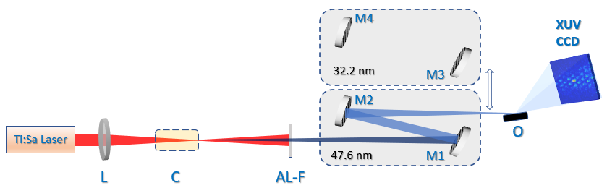
Figure 1. The optical layout of the XUV CDI experimental setup operating in reflection mode. L: Lens. C: Semi-infinite gas cell. AL-F: Aluminum filter. M1, M3: Flat multilayer mirrors. M2, M4: Concave spherical multilayer mirrors. O: Object.

- RESULTS AND DISCUSSION
Initially, we employed simulations to derive the expected diffraction pattern based on the optical geometry of our XUV CDI in reflection mode setup. Thus, we used an artificial honeycomb structure, similar to that of the MCP in use, and rotated it by 76.1º with respect to the honeycomb surface normal. The rotation of the object results in a geometrical shortening along the illumination direction, as shown in figure 2a. The simulated diffraction pattern is presented in figure 2b. Figure 2c shows the reconstructed object taking into account the 76.1º rotation. In the same figure, the honeycomb structure is shown overlapped with the reconstructed object for comparison. This analysis clearly shows that the reconstructed object consists of bright spots located at the center of the honeycomb MCP channels. Therefore, the reconstruction of the real object in our experiments using the two XUV wavelengths is expected to follow a similar pattern.

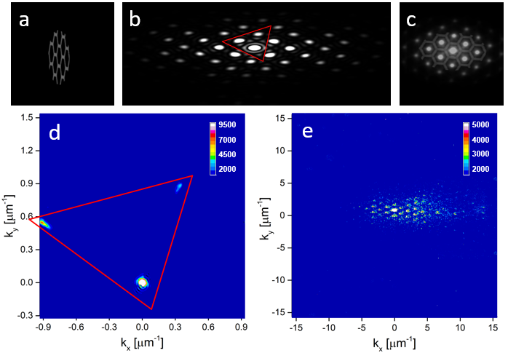
Figure 2. (a) Schematic of a MCP honeycomb object rotated by 76.1º to match the experimental viewing angle by the illuminating XUV beam. (b) The simulated diffraction pattern of (a). (c) The geometry-corrected reconstruction overlapped with the original MCP honeycomb object. (d) Experimentally recorded CDI image from the real MCP honeycomb object for a wavelength of 807 nm. (e) Same as in (d) but for a wavelength of 47.6 nm.

In Figure 2d the measured diffraction image obtained using the fundamental laser beam with a wavelength of 807 nm is shown. Only three diffraction spots are recorded on the CCD camera sensor, contained inside a red triangle that corresponds to the red triangle of the diffraction pattern of figure 2b. In figure 2e, a typical XUV diffraction pattern using the 47.6 nm wavelength is shown. Within the XUV CCD sensor, a high order diffraction pattern is recorded similar to that of the simulation in figure 2b.

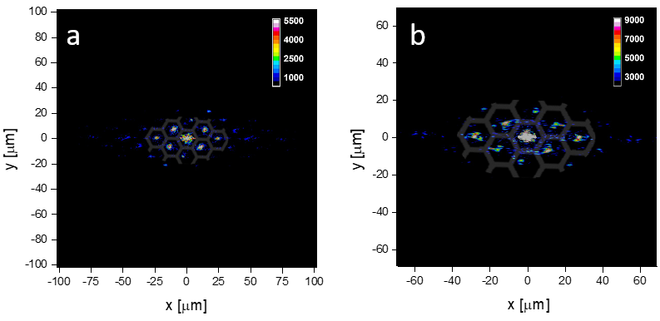
Figure 3. (a) Geometry-corrected reconstruction of the honeycomb MCP object using the XUV beam with a wavelength of 47.6 nm. (b) Same as in (a) but for a wavelength of 32.2 nm. The overlapped honeycomb pattern is a guide to the eye and corresponds to the actual MCP channel dimensions.

In Figures 3a,b the geometry-corrected reconstruction of the real MCP honeycomb object is presented, for 47.6 nm and 32.2 nm, respectively. The reconstructions of the object were developed using the RAAR algorithm (Luke et al., 2005), with a workflow structure similar to the one described in detail in our recent work on transmission XUV CDI (Petrakis et al., 2022b). As a guide to the eye, a honeycomb pattern with the same area of the object, scaled to the actual MCP channel dimensions, is overlapped to the reconstructed images. It must be mentioned that in figures 3a,b, each pixel corresponds to 200 nm and 140 nm, respectively, based on the analysis presented in (Dilanian et al., (2009), Prosekov et al., (2021)). As in the case of the artificial honeycomb structure, the reconstruction of the real MCP object consists of bright spots located at the centers of the MCP channels. Comparing the reconstruction in figures 3a,b, it is evident that the object is 1.5-times larger for 32.2 nm as compared to 47.6 nm, reflecting the inverse ratio of the wavelengths. Furthermore, using the shorter wavelength of 32.2 nm, object features can be resolved with a higher resolution since a higher number of pixels corresponds to the same bright spot areas.
Multispectral XUV CDI in reflection mode could be proven a powerful tool for spatiotemporal imaging of the evolution of the critical plasma density front, especially for the case where a high power laser illuminates a solid surface. Oscillating high crtitical density plasma surfaces are the mechanism for the relativistic high harmonic generation (Nomura et al., 2009). In this framework, ultrafast and high spatial resolution imaging of the critical plasma density evolution could be a unique tool for understanding the underlying physical mechanisms.

- CONCLUSION
In this article we have demonstrated multispectral XUV CDI in reflection mode of the surface of a MCP honeycomb structure. Our system is based on a versatile table-top high harmonic generation source where amplified fs IR laser pulses are focused onto atomic gas targets. The combination of appropriate XUV optics, such as specially designed multilayer mirrors, grazing incidence geometry, and reconstruction algorithms, allowed us to demonstrate that multispectral reflection CDI in the XUV is feasible. Prospects for using multispectral XUV CDI in dense plasma diagnostics have been discussed.

- ACKNOWLEDGMENT
This research was co-financed by the European Regional Development Fund of the European Union and Greek national funds through the Operational Program Competitiveness, Entrepreneurship and Innovation, under the call RESEARCH—CREATE—INNOVATE (project code: T1EDK-04549, project title: Development of a coherent X-ray multispectral microscopy system).

- REFERENCES
Clark, E.L. et. al., (2021). High-intensity laser-driven secondary radiation sources using the ZEUS
45 TW laser system at the Institute of Plasma Physics and Lasers of the Hellenic Mediterranean
University Research Centre. High Power Laser Sci. Eng., 245: 9, e53.
Dilanian et. al., (2009). Diffractive imaging using a polychromatic high-harmonic generation soft-x-
ray source. J. Appl. Phys., 106: 023110.
Gardner, D.F. et. al., (2017). Subwavelength coherent imaging of periodic samples using a 13.5 nm
tabletop high-harmonic light source. Nat. Photon., 11: 259–263.
Lewenstein, M. et. al., (1994). Theory of high-harmonic generation by low-frequency laser fields.
Phys. Rev. A, 49: 2117–2132.
Luke, D.R. (2005). Relaxed averaged alternating reflections for diffraction imaging. Inverse
Problems, 21: 37–50.
Miao, J., et. al., (2015). Beyond crystallography: Diffractive imaging using coherent x-ray light
sources. Science, 348: 530–535.
Nomura, Y., et. al., (2009). Attosecond phase locking of harmonics emitted from laser-produced
plasmas. Nat. Phys., 5: 124–128.
Petrakis, S., et. al., (2021). Electron quantum path control in high harmonic generation via chirp
variation of strong laser pulses. Sci. Rep., 11: 23882.
Petrakis, S., et. al., (2022a). Spectral and divergence characteristics of plateau high-order harmonics
generated by femtosecond chirped laser pulses in a semi-infinite gas cell. Atoms, 10: 53.
Petrakis, S., et. al., (2022b). Coherent XUV multispectral diffraction imaging in the microscale.
Appl. Sci., 12: 10592.
Prosekov, P.A., et. al., (2021). Methods of coherent x-Ray diffraction imaging. Crystallogr. Rep.,
66: 867–882.
Sandberg, R.L., et. al., (2007). Lensless diffractive imaging using tabletop coherent high-harmonic
soft-x-ray beams. Phys. Rev. Lett., 99: 098103.
Zurch, M., et. al., (2014). Real-time and sub-wavelength ultrafast coherent diffraction imaging in
the extreme ultraviolet. Sci. Rep., 4: 7356.

