First experimental measurements of the scintillator-based Fast-Ion Loss Detector in the MAST-U spherical tokamak

J.F. Rivero-Rodriguez¹, L. Velarde², T. Williams^{1,3}, M. García-Muñoz⁴,
K. McClements¹, D. Dunai⁵, J. Galdon-Quiroga⁴, J. Rueda-Rueda⁴, R. Scannell¹, E. Viezzer⁴ and the MAST-U Team
¹ United Kingdom Atomic Energy Authority, Culham Science Centre, Abingdon, UK
² Departamento de Ingeniería Energética, Universidad de Sevilla, Sevilla, Spain
³ Department of Physics and Astronomy, University of Exeter, Stocker Road, Exeter, UK
⁴ Departamento de Física Atómica, Molecular y Nuclear, Universidad de Sevilla, Sevilla, Spain
⁵ Wigner Research Centre for Physics, P.O.Box 49, H-1525, Budapest, Hungary

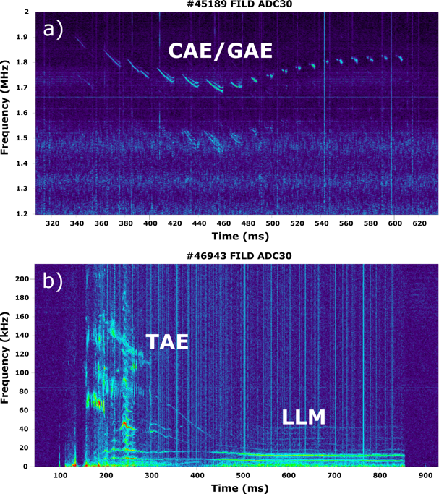
The first scintillator-based Fast-Ion Loss Detector (FILD) in MAST-U is equipped with a fast scintillator material, a high-resolution camera and an avalanche photo-diode camera that enable the inference of the fast-ion loss velocity space and fast-ion loss fluctuations at frequencies up to 2 MHz. The probe is installed on a rotary and reciprocating system that makes it possible to adapt the probe orientation to the plasma magnetic field pitch and radial position, respectively. The first measurements have revealed a clear dependence of the losses with the distance between the probe and the separatrix. The measured velocity-space of the neutral beam injection (NBI) prompt-losses agrees with estimates made using the ASCOT5 Monte-Carlo full-orbit code. Fourier analysis of the FILD signal revealed fast-ion losses from both on-axis and off-axis beam correlated with a wide variety of plasma instabilities, as can be observed in figure 1, such as toroidal Alfvén eigenmodes (TAE) and long-lived modes (LLM). Moreover, fast-ion losses in the range of 1 – 2 MHz have been revealed for the first time. These losses are correlated with fast-ion driven instabilities identified as either Compressional Alfvén Eigenmodes (CAEs) or Global Alfvén Eigenmodes (GAEs): their frequency is 0.3 – 0.45 times the cyclotron frequency of deuterium at the magnetic axis. Other plasma instabilities, such as sawteeth, fishbones and edge localized modes are seen to cause fast-ion losses. Measurements with a neutron camera and solid-state neutral particle analyser confirm the drops in the confined fast-ion population when the fast-ion losses are observed. These results show the unique capability of the MAST-U FILD to provide high-resolution measurements of fast-ion losses enabling a detailed physics investigation of wave-particle interactions in a spherical tokamak.
Figure 1. FILD spectrograms showing losses correlated with (a) CAE/GAE, (b) TAE and LLM.

* See author list of J. Harrison, et al. 2019 Nucl. Fusion 59 11201

