Diagnostic overview for the first operational phase of the SMART tokamak
D. J. Cruz-Zabala¹, E. Viezzer¹, M. Garcia-Munoz¹, A. Rodriguez-Gonzalez¹,
F. Puentes-del Pozo¹, J. Sanchez-Gamino¹, P. Vicente-Torres¹,
J. Salas-Suarez-Barcena¹, J. Galdon-Quiroga¹, M. Kaur², L. Delgado-Aparicio²,
A. Mancini¹, J. Segado-Fernandez¹, S. Munaretto², J. Berkery², M. Podesta², A. Diallo².
¹ University of Seville, Seville, Spain
² Princeton Plasma Physics Laboratory, Princeton, USA

In order to characterize the plasmas obtained in the Small Aspect Ratio Tokamak (SMART), a set of diagnostics is being developed for the first years of operation. SMART is a new spherical tokamak (ST) currently being assembled at the University of Seville. This new machine aims to explore a new possible path to compact fusion reactors: STs operating in negative triangularity (NT). NT plasmas in low confinement mode (L-mode) present positive triangularity (PT) high confinement mode (H-mode) like core confinement without edge localized modes (ELMs) [1,2]. The reduced heat loads achieved in NT relax the requirements for the heat exhaust, lowering the cost of the machine. STs can accommodate plasmas with high beta, and they are more compact than standard tokamaks, which also helps to reduce the cost of the reactor.

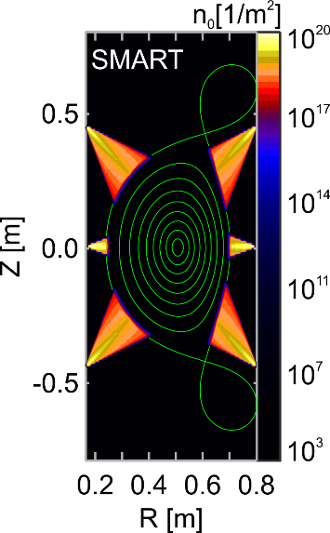
This contribution presents an overview of this set of diagnostics composed by the magnetics suite, a gas puff-based Charge eXchange Recombination Spectroscopy (CXRS) diagnostic, an interferometry system, a Thomson Scattering (TS) diagnostic, radiated power density (P_{rad}) measurements as using fast Si diodes, as well as visible spectrometers for impurity monitoring. The magnetics suite will allow us to reconstruct plasma equilibria and measure plasma instabilities. It is composed of Rogowski coils, Mirnov coils, poloidal flux loops, and diamagnetic loops. Impurity temperature, rotation and density measurements will be provided by the gas puff-based CXRS diagnostic [3]. A poloidal array of these systems is planned such that the poloidal variation of the impurity properties can be studied in NT and PT plasmas (see figure 1) with a radial resolution of ~ 3 mm and a temporal resolution of ~ 2 ms. To measure the line integrated electron density, a heterodyne interferometer will be implemented with three radial and three vertical chords using mm microwaves as its source. A synthetic model has been developed to aid in the study of time and density resolution. A 16-channel Thomson scattering (TS) diagnostic will be employed to measure local electron temperature and density in the mid-plane. The diagnostics measurement locations for TS, P_{rad} and visible spectrometer are arranged such that the edge pedestal can be resolved on the high-field and low-field sides in both PT and NT plasma scenarios. The design of the diagnostics above mentioned will be described and synthetic signals will be presented.
Figure 1. Initial distribution of neutrals produced by the poloidal array of CXRS systems.

[1] A. Pochelon et al., NF, 1999.
[2] M. Austin et al., PRL, 2019.
[3] D. J. Cruz-Zabala et al., JINST, 2019.

